* 

Athabasca rainbow trout; cumulative effects model and threat summary

Alberta Environment and Parks (AEP)

Update prepared by: (Body copy single spaced)

###

This report has been reviewed, revised, and edited prior to publication.

Alberta Species at Risk Report No. ##

Month 20##

Published By:

(all Body copy single spaced)

ISBN: XXXXXXX (Printed Edition) [only if printing hard copies]

ISBN: XXXXXXX (Online Edition)

ISSN: 1496-7219 (Printed Edition) [only if printing hard copies]

ISSN: 1496-7146 (Online Edition)

Series Editor: Robin Gutsell

Cover illustration: Artist/photographer’s Name (Brian Huffman if using existing line drawing)

For copies of this report, visit our web site at:

https://www.alberta.ca/species-at-risk.aspx

(click on “Species at risk resources”)

*OR*

https://open.alberta.ca/publications/#############

This publication has been released under the Open Government Licence:

<https://open.alberta.ca/licence>.

This publication may be cited as:

Lastname, A.B. 20##. Report title. Alberta Environment and Parks. Alberta Status at Risk Report No. ##. Edmonton, AB. ## pp.

EXECUTIVE SUMMARY

The Executive Summary will include a description of the rationale for the project, methods, key results, recommendations and future directions. This summary will be written for a broad audience. It should be able to stand alone as a summary of the project. The Executive Summary should not exceed one page in length.

Specific Joe modelling content considerations:

* Species info- where is it found in AB and in how many watersheds/waterbodies. Touch on the importance of assessing threats for this species
* Discuss the use of the FSA process (assess status and assess threats). A couple sentences to describe the model and how it was populated. What were the major threats across watersheds?
* What was the FSA status of this species? Did it align well with the model?
* A few sentences on how this threats summary can be used to inform recovery of and adaptive management experiments

Athabasca rainbow trout are native to 19 HUC8 watersheds in Alberta’s foothills and mountains within the upper Athabasca River basin. This unique fish is considered by COSEWIC as a “designatable unit” and is federally classified as “Endangered” under the Species at Risk Act (SARA) and by Alberta Environment and Parks as “Threatened” because of severe declines in abundance. Recovering the populations of this fish requires addressing the cumulative effects of numerous land use and human threats as described by the 2014 Athabasca rainbow trout recovery team.

Alberta’s Fisheries Sustainability Assessment (FSA) was used to assess the current status, and threats to Athabasca rainbow trout using a simple cumulative effects model that combined 18 different threats, including those described by the 2014 recovery team, as well as recent threats such as whirling disease. The cumulative effects model was populated with data specific for each of the 19 populations. For tactical level recovery modelling, these 19 HUC8 watersheds were further broken down and the cumulative effects model was populated with data specific to 90 HUC10 watersheds that nested within them. The data was derived from landscape-level GIS information, water quality data, flow data and professional estimates. This data and formal sensitivity analysis was used to predict the modelled status of Athabasca rainbows in each watershed and describe the quantitative level of each threat. In general, the largest threats were from human-caused sediment, stream fragmentation, non-native species, and overfishing.

Assessing the status of Athabasca rainbow trout showed that all 19 populations had declined, and no populations were at moderate to low risk. Modelled adult status aligned well with measured status. The objective of the 2014 recovery plan required that 2 or more of these populations must be increased to low risk.

The summarized watershed-specific threat assessments highlight the recovery potential of several watersheds. Through adaptive management, recovery actions to reduce threats can be operationalized in priority watersheds, and the goal of the 2014 recovery plan could be met. These proposed actions include using best-management practices to reduce sediment run-off in portions of the Berland and Wildlhay watersheds, replace hanging culverts in the Berland and Wildhay, conduct “clean and move” projects (i.e., chemical removal of non-native fish, followed by transfers of native fish from adjacent streams) in select streams in the Upper MacLeod watershed, and conduct a reversal of fishing closures/fishing openings in the Upper McLeod watershed working with stakeholder stewards.

ACKNOWLEDGEMENTS

Include partners, volunteers, staff who worked on the project, reviewers, people who provide data, etc. Where appropriate, please include the affiliation (in parentheses) with each individual’s name.

Preparation of this updated report was funded by Alberta Environment and Parks.

DISCLAIMER (***optional)

A disclaimer should be used for reports prepared by a consultant. The disclaimer should read “**The views and opinions expressed are those of the author(s) and do not necessarily represent the policies or positions of the Department or the Alberta Government.**” The disclaimer should not be necessary when the author is an employee of the Department (employee needs to make sure the report is compatible with department and government policy). Even when the author is a consultant, the project lead needs to make sure the contents of the report are compatible with department and government policy. An example follows in the next paragraph:

The views and opinions expressed in this report are those of the author and do not necessarily represent the policies or positions of Alberta Environment and Parks, the Alberta Fish and Wildlife Policy Branch, or the Alberta Government.

Table of Contents

Introduction (TOC section) 1

Study Area 2

Methods 3

Results 15

Subheading 15

Subheading 15

Subheading 16

Subheading 17

Discussion 23

Subheading 23

Subheading 23

Subheading 23

Management Implications and Future Directions 23

Literature Cited 23

Appendix/Appendices 23

List of Figures (Subheading second level)

List of Tables (Subheading second level)

Introduction

The purpose, reason or rationale for the study. Include the project objectives and any relevant background information. Provide information on the status of the species involved, how the project fits into the overall program, and fits into a recovery plan or management plan. The introduction will provide a description of why the project was done and explain how it contributes to the assessment, recovery or management of the target species.

Specific Joe modelling content considerations:

* Introduce us (briefly) to this fish species. What is its range? Does it have any federal or provincial conservation designations?
* How are we defining a ‘population’ and why? Refer to relevant genetic information and the HUC level of assessment (note: most of this information has already been collated in the FSI species-specific thresholds document)
* What were previously identified threats? If applicable, refer to previous recovery plan. Highlight the complexities of understanding and quantifying which threats are limiting fish populations
* Brief overview of FSA and Joe model, the usefulness of the results and how needs to be implemented via adaptive management
* The objectives

Rainbow trout are a widespread and generally abundant fish in Canada’s Pacific coast drainages. However, only three groups of rainbow trout are naturally occurring in Arctic drainages east of the continental divide (McPhail 2007; Behnke 2002). One of these groups is only found in a small area of Alberta’s mountains and foothills, in the upper Athabasca River watershed (Nelson and Paetz 1992). Although this fish is not a distinct sub-species (McCusker et al. 2000; Taylor et al. 2007), it is considered a unique ecotype and is managed as a designatable unit (Taylor and Yau 2013; COSEWIC 2014). Athabasca rainbow trout have shown severe declines from historical abundances (Rasmussen and Taylor 2009) and is currently designated as *Endangered* under the federal Species at Risk Act (SARA) and as *Threatened* by Alberta Environment and Parks.

We refer to groups of Athabasca rainbow trout living in different watersheds as “populations”. For our management purposes, the term “population” is used as a functional compromise between the strict genetic definition of interbreeding individuals and the logistical constraints of management (such as scale of abundance monitoring, habitat mitigation, and regulation setting). Within this compromise, we use watershed boundaries to define the geographical scale of the functional populations. For Athabasca rainbow trout, the functional size of watersheds is the Hydrological Unit Code (HUC) of 8. At this scale, there are 19 HUC 8 watersheds within provincial and national park boundaries inhabited by Athabasca rainbow trout in Alberta, therefore we refer to these as 19 populations. However, for tactical level recovery modelling, these 19 populations were further broken down and the cumulative effects model was populated with data specific to smaller 90 HUC10 watersheds that nest within them.

Recovery of Athabasca rainbow trout is a priority of stakeholders, including the Alberta government, Department of Fisheries and Oceans, Parks Canada, as well as a variety of public and commercial interests in this area. These groups, designated the Alberta Athabasca Rainbow Trout Recovery Team (AARTRT), developed a recovery plan in 2014 which described their vision of the main threats to Athabasca rainbow trout (AARTRT 2014). These primary threats were habitat loss and degradation, and introgression and competition from non-native species. The goal of the plan is increase the trout populations through habitat improvements and reductions of introgression and competition. The stated goals of the Recovery Team have quantitative thresholds, i.e., “increase the number of Athabasca rainbow trout populations in low risk categories by a minimum of 10%; reverse the trend of an increasing number of populations in high risk categories” (AARTRT 2014). The threats and actions described by the Recovery Team, however, were mainly qualitative, rather than quantitative.

The diversity of potential threats as described by the Recovery Team was long and complex, with over 30 threats listed and described. Understanding which threats were limiting the trout populations and developing mitigation for these threats was a goal proposed by the Recovery Team, but was stated without specifying direct actions to achieve this understanding. This is a common dilemma faced by most fisheries managers when dealing with complex scenarios of cumulative effects; how to separate and quantify the long list of possible threats with any realistically limited research budget.

Recent assessments of fish in Alberta, including Athabasca rainbow trout have used a quantitative technique, referred to as the Fish Sustainability Assessment (FSA) (CSAS ref) to assess the status and threats to fish populations. This assessment derives a quantitative metric for adult fish abundance, and compares this to estimates of unexploited abundance. Additionally, this quantitative technique simplifies the development of stressor-response curves for threats to the status of assessed fish. By combining these stressor-response curves, a model of cumulative effects (the Joe model) is easily developed.

The objectives of this report are to:

1. Summarize the assigned quantitative conservation status to each of the 19 populations of Athabasca rainbow trout in Alberta
2. Document the development of a series of land use-based stressor-response curves that are then combined into a cumulative effects (CE) Joe model describing the best-available scientific hypotheses for estimating the status of a sub-population of Athabasca rainbow trout
3. For each sub-population, quantify the specific land use parameter (i.e., stressor) in each stressor-response curve in the CE model.
4. Provide a summary of major threats for each of the sub-populations. Discuss sub-populations that are hypothesized to respond to management actions by significantly increasing their conservation status, helping to achieve recovery goals.

Methods

Provide a description of the methods used for the project. The description must be in detail sufficient to enable the reader to duplicate the study and obtain results that can be compared with the original report (especially for inventory projects).

Specific Joe modelling content considerations:

* This should provide a brief overview of the FSA, the conceptual model, what it predicts and how that information can be used. Will reference the CSAS publication in case readers want a more detailed explanation.
* Why specific threats were included, how stressor-response curves are created, and the individual stressor response curves and their documentation
* Modelling uncertainty

Alberta’s FSA and Cumulative Effects Joe Model: The Concept

A full description of Alberta’s Fisheries Sustainability Assessment (FSA) and Joe modelling technique can be found in [ CSAS REF). Briefly, the FSA is a two-part process: 1) Assess Status: current status is scaled to a provincial reference condition, and 2) Assess Threats using simple cumulative effects models (called Joe Modelling*)*: model the hypothesized threats to achieving desired status.

For assessment, fish populations are scored into density categories of 0 (extirpated) to 5 (very high density). The thresholds for each category are set based on a declining scale from the highest density (assumed to be relatively unexploited and undisturbed) populations. The categorical scale is based on the IUCN/COSEWIC population categories of 0-30% below high density (low risk, FSA score of 4), 30%-50% below high density (moderate risk, FSA score of 3), 50%-80% below high density (high risk, FSA score of 2), and >80% below high density (very high risk, FSA score of 1) (Table 1). Populations are defined as species-in-lakes, and species-in-watersheds, such as “northern pike in Lac Ste. Anne”, or “bull trout in the Wildhay River watershed”. Standardized index-netting in lakes and electrofishing in rivers are primarily used to determine population density, as scored in relation to provincial-level thresholds. This simple score comparison, current versus undisturbed, provides a critical perspective to minimize shifting baselines, and standardizes the interpretation of provincial fish status across species and watersheds.

**Table 1.** Proportion of a population remaining compared to a theoretical population undisturbed by anthropogenic influences, and the corresponding Alberta Fisheries Sustainability Assessment (FSA) scores



Alberta cumulative effects Joe models are a series of stressor-response curves representing impacts and limiting factors that are combined to simulate and quantify the cumulative effects on the system capacity of a fish population. Each model consists of a series of stressor-response curves where each impact is treated as independent, with the identified impact as the stressor and output from the curve is system capacity. The resultant cumulative threats assessment defines the capacity of the system to achieve a certain stable state; e.g., if threats are all high, the best state the population might achieve is low density. Prior to using this output for the Joe model, system capacity must be scaled to the reference condition for the response metric. The response metric for each stressor is then multiplied together to develop the cumulative adult response (Figure 1). System capacity (i.e., the response metric) is the resulting proportion (0-100%) of the reference condition.

Each impact is initially developed and modelled independently through a stressor-response curve that predicts system capacity. The combination of impacts (i.e., system capacity from each stressor-response curve) are: a) represented as a fraction of the reference condition (i.e., response metric); and, b) response metrics for each stressor are multiplied to get an overall proportion of the reference condition (Figure 1). Although this sounds somewhat complicated, it simply describes an additive cumulative effects model on a proportional scale, which is the sensible biological scale if each impact influences survival independently. Weighting of individual impacts is not necessary because each impact is quantified as acting on the same output parameter: the common and dimensionless response metric (system capacity). Weighting impacts has long been a difficulty of traditional cumulative effects models (Walters 1997). The novel approach of Joe Modelling simplifies that difficulty.

Alberta’s cumulative effects Joe Models are not designed to be complex ecosystem-level models that capture synergistic or antagonistic interaction among impacts. They are also not meant to replace localized action plans requiring tactical, fine-scale, specific-site data. Rather, these are strategic, population-level models using the best available science to create reasonable hypotheses of cumulative effects and management actions. As such, the output from these models are treated not as forecasts, but as best available hypotheses whose predictions need to be tested and validated.

The novel and effective value of the Joe Modelling concept is in these two points: 1) any number of impacts or “stressors” can be efficiently added to the model; and 2) the potentially complex weighting of impacts is accomplished by simply using one easily measured output response metric. As such, Joe Modelling provides a useful bridge between listing all potential threats (as typically conducted in species at risk planning), and detailed quantitative fisheries population dynamics models that include threats of predicted high importance.

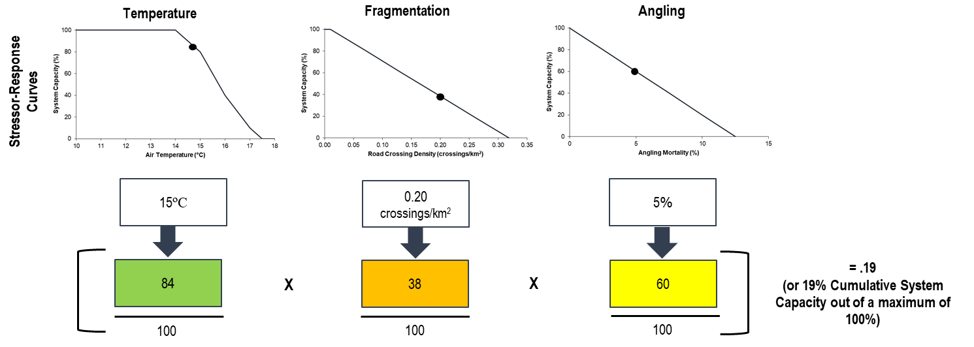

**Figure 1.** Illustration of the multiplicative effect of three hypothetical stressor-response curve (impacts) on predicted cumulative adult system capacity. Figure adapted from [insert CSAS ref]

The Stressor-Response Curves

* Discuss why specific threats were included in the model.
* How stressor-response curves are created

‘In the Recovery Plan (AARTRP 2014), six broad categories of threats were listed, with 30 specific threats described within these categories. During the modeling workshop in November 2015, participants discussed these threats and quantified them into 17 distinct stressor-response curves’.

These curves were developed using the best-available data at the time, including analysis of spatial data (i.e., in-house GIS or using ALCES Online©), fisheries data available in the provincial Fisheries and Wildlife Information Management System database (FWMIS), and consensus of professional opinion developed during workshops. While the workshop bound the stressors to be included in the model, fisheries biologists undertook the lengthy task of combing through data and scientific works to support, refine, identify key uncertainties, and document the rationale for individual stressor-response curves. Of note, curves were developed at the appropriate scale in space and time, and modelled at the population-scale for the focal species. For each curve and input parameter value, a formal uncertainty analysis is conducted and is detailed below. It is expected that there will be refinements to the curves and potentially more (or less) complex interactions between threats as new information is generated during the adaptive management process.’

Modelling Uncertainty

As outlined in (CSAS ref), by explicitly acknowledging uncertainty and formalizing sensitivity analyses in Joe Modelling, fisheries biologists can improve their understanding of the potential consequences of uncertainty on the robustness of their conclusions. Critically, however, the model outputs are never “predictions with certainty”. They are simply the logical result of explicitly stated inputs. Key drivers might be entirely unknown, stressor-response curves may be unique and unknown, and input variables may change significantly from year-to-year. The value of modelling is to demonstrate the effect of uncertainty, not eliminate it.

Formal sensitivity analysis can be conducted during the model design phase to determine which stressors cause the most sensitive changes to the model output. The objective is to focus work, such as literature reviews or field studies, on parameters where reducing uncertainty can be most efficient and effective. In brief, understanding the sensitivity of Joe Modelling to stressor levels and stressor-response curves could be done by:

1. Adjusting stressor levels (input parameters) by a constant proportional amount to determine which have the largest output effect. Stressors with the largest effect require particular attention to uncertainty in their input values.
2. Redefine the stressor-response curves to produce a range of curves around the most likely curve to determine its effect on output. However, this is better tackled through more formal methods such as Bayesian networks (Scutari and Denis 2015) and is beyond the scope of the current Joe Models.

When pairing Joe models with management actions, a robustness analysis should also be conducted. That is, ensure that the model output is robust to the uncertainty in critical input parameters and curves. This analysis addresses the requirements for quantifying uncertainty within the Management Strategy Evaluation process. A detailed description of modelling Joe model uncertainty is found in [CSAS REF).

Individual stressor e.g. Small Stream Fragmentation

* Discuss each individual threat and why it’s important to this fish species. Should be considered a summary of any relevant literature
* Summarize any analysis used to inform the shape of the stressor-response curve.
* Data input: where did the data come from? Provide as much detail as possible without going overboard. Detailed internal technical memos can be created if necessary to supplement this information. Generally though, you want someone to be able to replicate your analysis using this information.
* [Insert figure of stressor-response curve (see accompanying excel spreadsheet for figure and table templates)]
* Detail formal sensitivity analysis on input value and SR curve and how we came up with each.

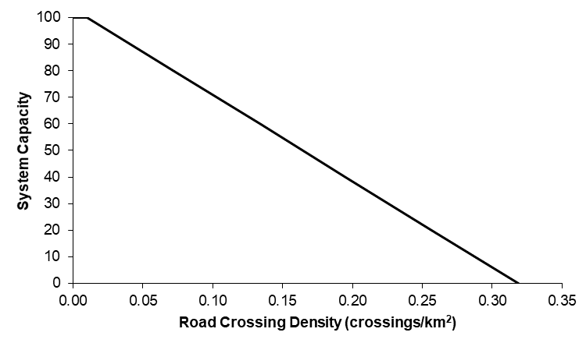

**Figure X.** Stressor-response curve depicting the expected relationship between [insert stressor] within a watershed/lake and the system capacity of [insert species] populations. System capacity (0-100%) is a measure of adult density relative to a maximum capacity of 100%.

Natural Limitations: Temperature

Athabasca rainbow trout is a thermally sensitive cold water species, with a narrow range of thermally preferred habitat, apparently colder than most other strains of rainbow trout (Rasmussen and Taylor 2009).

A stream temperature model was created using a step-wise multiple linear regression model. This incorporated mean summer (August and September) air temperature and land use co-variates found in ALCES Online© to create a basin specific (Athabasca River) model (MacDonald AO ref). The thermal characteristics of Athabasca rainbow trout habitat in Alberta were explored by intersecting the modelled mean summer stream temperatures to all locations where rainbow trout have been captured between 1946-2014 (FWMIS query, April 2015; Figure XA). Modelled stream temperatures were used in this analysis because there is currently no province-wide water temperature dataset available. Of note, updated spatial stream network (SSN) temperature models are currently in development, but were not yet complete for use in this version of the Joe model. We expect that refinements to the stream temperature model stressor-response curves and watershed input values will occur once these models are complete.

The optimum average summer water temperature thresholds (6-12°C, Figure xA) were cooler to thermal preferences listed by other authors (e.g. 7-18°C for adult holding and feeding (Kwain 1975), 10-18°C as preferred thermal habitat (Scott and Crossman 1998), 12-18°C for adult feeding and holding (Raleigh et al. 1984)), but this could be an artifact of the stream temperature model which will be refined as it is validated as additional real stream temperature data from across the Athabasca drainage becomes available. The findings of this analysis were used to inform the shape of the stressor-response curve below, which characterizes the expected influence of both cold and warm temperature on the status of Athabasca rainbow trout populations (Figure XB). The rapid decline in the number of occurrences between 8 to 6°C is likely due to sampling bias (i.e., there are fewer sampling events in cold, high-elevation areas that are difficult to access; also rainbow trout are found in a handful of colder waters within Jasper National Park but that data is not included in the analyses). However, in visually inspecting stream temperatures in colonized Jasper National Park streams with excellent Athabasca rainbow trout populations they fall within the modelled 5-8°C temperature range. Therefore, lotic habitats with these colder temperatures were still considered to be excellent Athabasca Rainbow Trout habitat.

Joe Model Data Input: An average modelled mean summer stream temperature (°C) provided by ALCES Online© for the spatial unit of interest (e.g., HUC 10 watershed).

1. 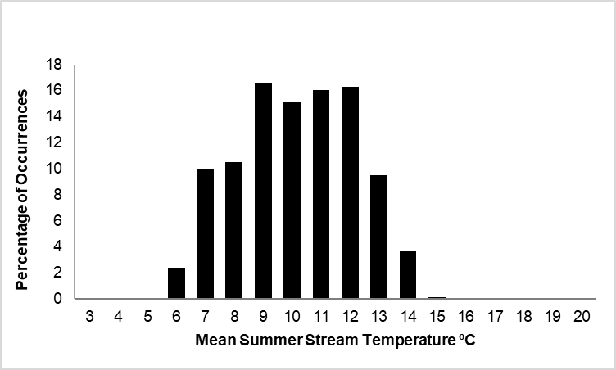 **B)**

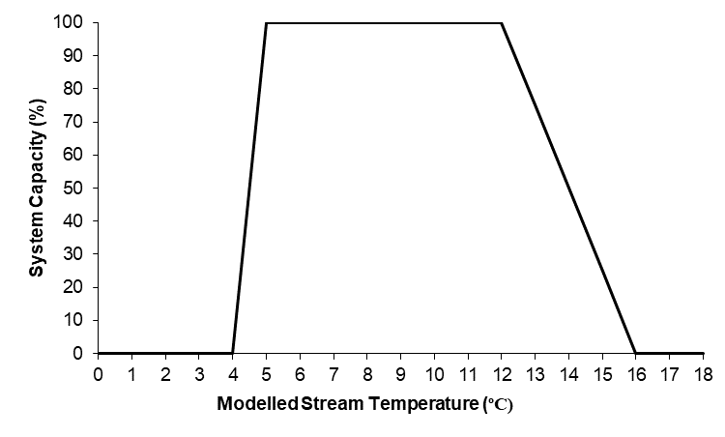

**Figure X A)** Thermal range of occupied Athabasca rainbow trout waters within historic range. **B)** Stressor-response curve depicting the expected relationship between modelled mean summer stream temperature and the system capacity of Athabasca rainbow trout populations. System capacity (0-100%) is a measure of adult density relative to a maximum capacity of 100%.

* Detail formal sensitivity analysis on input value and SR curve and how we came up with each.

Natural Limitations: Other

Athabasca rainbow trout are naturally limited by other environmental variables besides air and water temperature. These limitations occur at varying spatial scales and include both biotic (e.g., productivity, fish community, etc.) and abiotic features (amount of woody debris, substrate composition, water velocity, groundwater input, natural sediment loads, natural flow regimes, etc.). Further, persistence in suitable, but isolated habitats may be limited if connectivity with neighbouring populations is restricted. Understanding the influence of natural limitations on Athabasca rainbow trout populations today is difficult due to the confounding spatial and temporal effects of human disturbance and harvest. However, the relative status of Athabasca rainbow trout prior to extensive human disturbance and harvest was estimated as the FSA score for Historic Adult Density. That score can therefore be used as a best-available science estimate of overall natural limitations to system capacity within each watershed in the species historic range (Figure x).

Joe Model Data Input: Historic Adult Density FSA score. There is no historic (i.e., >100 years) fisheries survey data; therefore, anecdotes, photographs, local environmental knowledge (LEK) and traditional environmental knowledge (TEK) were used to inform scores of system capacity. This included historical accounts from warden reports and angler interviews. Please note, these natural limitations rankings should only reflect limitations other than temperature. Therefore, historic adult density scores may be exceeded if temperature was noted as limiting and climate change warms the water.

**Figure X** Stressor-response curve depicting the expected relationship between historic adult density FSA score (converted to system capacity) and the system capacity of Athabasca rainbow trout populations. System capacity (0-100%) is a measure of adult density relative to a maximum capacity of 100%.

* Detail formal sensitivity analysis on input value and SR curve and how we came up with each.

Direct Mortality

There can be several causes of direct mortality among Athabasca rainbow trout in a population, including natural causes, entrainment, angling, and research/monitoring activities. The total annual mortality rate (A) can be calculated using the conditional rates of natural mortality (n), angling mortality (m), indigenous peoples harvest (i), entrainment mortality (en) and research and monitoring mortality (r) by applying the following equation adapted from Ricker (1975):

A = 1 – [(1-n)*(1-m)*(1-en)*(1-r)*(1-i)]

The stressor-response curve for direct mortality (Figure x) is based on the results from modelling using a modified version of the Bull Trout model of Post et al. 2003. This model was modified for stream trout for the assessment of rainbow and cutthroat trout populations in Alberta foothills streams (Sullivan 2007). Assuming a conditional mortality rate of 35% from natural causes (Post et al. 2003; Sullivan 2007) an Athabasca rainbow trout population may be at high risk of extirpation if the combined conditional rate of mortality from other sources exceeds 15% (Figure x).

**Figure X** Stressor-response curve depicting the expected relationship between annual mortality (in addition to 35% natural mortality) and the system capacity of Athabasca rainbow trout populations. System capacity (0-100%) is a measure of adult density relative to a maximum capacity of 100%.

1. *Incidental Angling Mortality and Illegal Harvest*

Athabasca rainbow trout were legally harvested, albeit with a large size limit, throughout the eastern slopes in accessible watersheds prior to 2014 and the implementation of widespread zero harvest regulations for rainbow trout in the Athabasca rainbow trout natural range. Angling, however, may still represent a major threat to population sustainability from incidental mortality (i.e., mortality due to stress or physical damage from hooking or improper handling) in spite of catch-and-release regulations. Illegal harvest, either intentional or due to misidentification, may also contribute to population declines. The combination of incidental mortality and illegal harvest will be unsustainable if angling effort is sufficiently high (Post et al. 2003). Past case studies demonstrate that in east slope streams and lakes, some but not most bull trout populations are capable of recovering relatively quickly (5-10 years) from an over-exploited state under zero harvest regulations and complete angling closures (Johnston et al. 2007; Sullivan 2014; Reilly et al. 2016). Widespread recovery of Athabasca rainbow trout populations has not occurred, however, no recently collapsed populations are managed under closed regulations.

At the long-term study of Athabasca rainbow trout at the Tri-Creek study area, near Cadomin, trout densities are the highest recorded in the fishes’ natural range. These streams have been closed to angling since the 1960s. In adjacent streams (Antler and Mary Gregg creeks) that are open to angling under effectively catch-and-release regulations, the density of trout is 50% to 80% below that of the unfished streams (Wampus and Deerlick creeks). This suggests that even catch-and-release angling has the potential to result in significant decreases in Athabasca rainbow trout densities (Rasmussen and Taylor 2009).

For the purposes of the modelling and hypothesis-generation process, an estimate of potential catch-and-release mortality was based on the initial FSI assessment of “Overharvest Protection Need”. This parameter was derived from road density, ease of access, and proximity to centres of public and anglers.

Joe Model Data Input: The ‘Overharvest Protection Need’ parameter in the 2015 Athabasca rainbow trout FSI was ranked based on the proximity of human settlements and the amount of access (e.g., road density, road type, road location) to flowing waters in each HUC8 (AEP 2017 in prep). These ranks were translated to estimated effects of conditional angling mortality rates on system capacity using the following approach: Rank 1 (very high risk) = 30% mortality rate ; Rank 2 = 16.25% mortality rate; Rank 3 = 10% mortality rate; Rank 4 = 6.88% mortality rate, Rank 5 (very low risk)= 0-5% mortality rate. Assigned mortality rates were modified if any creel information was available (rarely) or using professional opinion. HUC8 mortality estimates were applied to their individual HUC10 watersheds and then often refined by local area biologists to reflect specific characteristics of the smaller spatial scale watersheds.

Detail formal sensitivity analysis on input value and SR curve and how we came up with each

1. *Entrainment Mortality*

Athabasca rainbow trout can become entrained in diversion canal headworks and killed if not rescued before the canal is dewatered at the end of the irrigation season. There have been no studies to determine the total number of entrained Athabasca rainbow trout and the overall effect on population sustainability. However, in southern Alberta with very extensive diversion of flowing waters, the Trout Unlimited annual fish rescue program typically records small numbers (<10) of entrained bull trout (Lindsey et al. 2015), with at least one notable past exception in the Belly River where entrainment was estimated at 15 – 20% of annual mortality (Clayton 2001) prior to screening. No large-scale irrigation or diversion projects occur in Athabasca rainbow trout ranges at this point, but streams diversions for coal mining and petrochemical extractions can occur.

Trout can also become entrained in powerhouses for hydroelectric reservoirs where a portion are killed as they pass through the turbines. No information is available for entrainment of Athabasca rainbow trout, but bull trout entrainment has been more extensively studied. Various aspects of bull trout entrainment in hydroelectric reservoirs have been widely studied in both the U.S. and British Columbia (B.C.) (Martins et al. 2013, Ma et al. 2012, Underwood and Cramer 2007, Salow and Hostettler 2004, and FERC 1995). Entrainment and mortality rates are highly site-specific, varying with physical factors including reservoir size, dam height, fore bay configuration, depth of intake, turbine type and operational timing as well as biological factors including fish size, seasonal and diurnal movements and density-dependent influences on fish movement. While few generalizations can be made, entrainment rates of adult, sub-adult or juvenile bull trout can and do impact populations typically as annual losses (i.e., direct morality and permanent loss to downstream reaches) of <5%. For example: 1) Kinbasket Reservoir, B.C., adult Bull Trout - 3.4% loss (Martins et al. 2013); 2) Arrowrock Reservoir, ID, adult Bull Trout - 4% loss, 11% loss when drawn down for maintenance (Salow and Hostettler 2004), and 3) Rimrock Reservoir, WA, sub-adult bull trout- 1.4% loss (Underwood and Cramer 2007). Substantially greater mortality rates (9 – 42%, size dependent) are anticipated for the Peace/Halfway River bull trout population during the operation of the Site C Dam in B.C. (Ma et al. 2012).

No large-scale hydroelectric projects are currently in operation within the natural range of Athabasca rainbow trout. However, plans for hydroelectric and diversion dams are commonly proposed, such as proposals for dams on the Athabasca River and major tributaries (Hatch 2010).

The stressor-response curve (Figure x) is based on modelling work completed by Sullivan (2007) who demonstrated that stream trout switch from growth overfished to recruitment overfished at approximately 45% total annual mortality. These findings can be easily translated to describe the expected effects of entrainment. For example, if 35% natural mortality is assumed, an annual entrainment rate of 4% may result in a population at low to moderate risk of extirpation.

Joe Model Data Input: In general, watersheds containing or proposed to contain hydroelectric dams (none at present) were assigned a rate of 4%, unless other data were available.

Detail formal sensitivity analysis on input value and SR curve and how we came up with each

1. *Research and Monitoring Mortality*

Standard scientific methods for monitoring Athabasca rainbow trout populations typically involve the non-lethal capture, handling and release of individual fish. Methods used to capture Athabasca rainbow trout include electrofishing, angling, trapping and netting, with backpack electrofishing being the most widely used. After capture, fish are held for processing, anesthetized, and measured. Depending on the project objectives, fish may also be marked (tagged), surgically implanted with telemetry transmitters, and/or have a small portion of the adipose fin removed for genetic analysis. Lethal sampling of Athabasca rainbow trout is uncommon, but may occur if information that cannot be collected using non-lethal means (e.g., maturity and age data) is required for management and assessment purposes. In these cases, the potential impacts on population sustainability are thoroughly reviewed by Fisheries Management staff prior to project approval.

Alberta Fisheries Management has developed a series of standards including the Standard for the Ethical Use of Fish in Alberta (AESRD 2013a), Standard for Sampling Small Streams in Alberta (AESRD 2013b) and Electrofishing Policy Respecting Injuries to Fish (AFMD 2004) in order to minimize fish injury, stress and mortality during non-lethal collection and handling by research crews. These standards are included as conditions on Fish Research Licences, which are mandatory licences issued to all agencies and organizations conducting fisheries-related work in the province. Fish Research Licences also include a section detailing Best Management Practices relating to the processing of fish in cold and hot weather, proper handling techniques, and the use of anaesthetic. While the application of standards and best management practices does minimize fish injury, stress and mortality, some incidental mortality during fish collection and handling may occur.

Researchers and biologists working on species-at-risk should also follow a high ethical standard. Although the quantitative mortality from research may be insignificant, stakeholders and the fish should expect a respectful and precautionary approach by biologists. To this end, biologists are cautioned against practises such as holding fish for long periods, using bait in research angling, and needlessly increasing sample sizes of handled fishes.

Incidental mortality is assumed to have negligible to very low population-level effects because the majority of Athabasca rainbow trout surveys are limited to small representative areas of a watershed and project time periods are typically short (1-5 years). Similarly, for bull trout, the U.S. Fish and Wildlife Service analyzed the effects of scientific research through a biological opinion survey (USFWS 2000) and determined that scientific collecting does not jeopardize bull trout populations, and is therefore not identified as a threat factor in the U.S. bull trout recovery plan (USFWS 2014). Similar to bull trout, we suspect that scientific research and monitoring has little to no effect on Athabasca rainbow trout population sustainability, and at our most heavily studied systems (e.g. Tri-Creeks) have yet to detect any population-level effects of monitoring activities. Nonetheless, this parameter is included in the model and the level of research and monitoring mortality is included in the calculations.

Joe Model Data Input: Conditional rate of mortality due to research and monitoring was set to 0% unless other data were available. Values will be adjusted if new research becomes available suggesting otherwise.

Detail formal sensitivity analysis on input value and SR curve and how we came up with each

1. *Indigenous Peoples Harvest*

Harvesting of fish for food and ceremonial purposes by Indigenous persons with aboriginal Treaty rights is the highest priority use of fish in Alberta (GoA 2015). The primary means by which this use is managed is through the issuance of domestic fishing permits, which authorizes the use of gillnets in specified waters, following certain rules put in place for conservation. No netting permits have been issued in recent periods that may result in significant harvest of Athabasca rainbow trout. Consultation with Indigenous peoples’ have been ongoing to discuss including angling (and other methods) as a means of fishing. If these methods become accepted, and trout populations increase enough to allow sustainable and efficient harvesting there may be an increased interest by Indigenous peoples to catch Athabasca rainbow trout.

Indigenous peoples’ harvest of Athabasca rainbow trout is rarely reported by Enforcement Officers, biologists, or in discussions with local residents. Indigenous peoples’ harvest, however, was included to allow scenarios of allocating fish between user groups to be explored.

Joe Model Data Input: Conditional rate of mortality due to Indigenous harvest was set to 0% unless other data were available.

Detail formal sensitivity analysis on input value and SR curve and how we came up with each

Fragmentation: Stream Crossing Structures

Athabasca rainbow trout can exhibit migratory behaviours that require connectivity between key spawning, rearing, feeding and overwintering habitats. Improperly installed road crossings can cause immediate and long-term effects on fish populations by providing increased angler access, altering habitat characteristics, fragmenting fish habitat and impeding fish movements necessary to complete life history processes (Warren and Pardew 1998; Gunn and Sein 2000; Harper and Quigley 2000; Morita and Yamamoto 2002; Park et al. 2008; Burford et al. 2009; MacPherson et al. 2012).

Several audits of crossing structures in northwestern Alberta watersheds reported that approximately half of assessed culverts were considered potential barriers to fish passage (Park et al. 2008; Johns and Ernst 2007; Scrimgeour et al. 2003).

In the absence of a provincial crossing status dataset, we assumed that relatively high road and stream crossings intersections indicate a greater risk of habitat fragmentation. There is a paucity of studies directly measuring population-level impacts of fragmentation on Athabasca rainbow trout, although road density has been positively associated with reduced occupancy of the bull trout (Ripley et al. 2005) and is correlated with road crossing densities within watersheds in the bull trout range (r2=0.59, J. Reilly unpublished). The hypothetical relationship between road crossing density and Athabasca rainbow trout status (Figure x) was determined following the risk threshold approach outlined in MacPherson et al. (2014) using the highest estimated road crossing density (0.257 crossings/km2) to indicate the greatest degree of extirpation risk. We expect that the hypothesized relationship between road crossing density and Athabasca rainbow trout status would be similar to that of bull trout.

Joe Model Data Input: Number of road and stream intersections per watershed were estimated using the provincial road spatial layer, excluding winter roads and ferry crossings. Only Order 2 and 3 streams were considered because Athabasca Rainbow Trout occur infrequently in Order 1 streams (FWMIS query, Nov. 2015) and crossing structures used on streams Order 4 and greater are typically bridges that do not limit fish passage (e.g., Park et al. 2008).

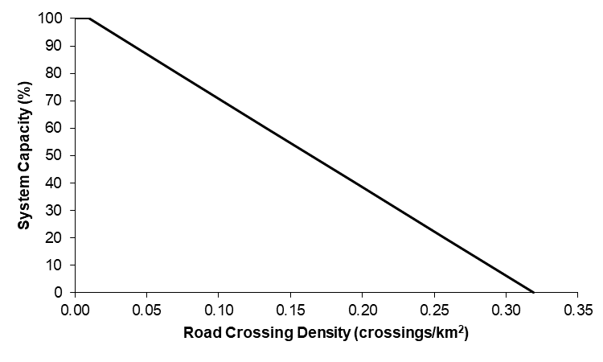

**Figure X** Stressor-response curve depicting the expected relationship between road crossing density of stream orders 2 and 3 and the system capacity of Athabasca rainbow trout populations. System capacity (0-100%) is a measure of adult density relative to a maximum capacity of 100%.

Detail formal sensitivity analysis on input value and SR curve and how we came up with each

Fragmentation: Large Barrier Dams

Dams that are not equipped with fish passage facilities can act as barriers to upstream and downstream fish movement, which reduces or eliminates access to required habitats and gene flow (ASRD 2012). The overall effect of fragmentation on the sustainability of a fish population depends on: 1) patch size, or the proportion of habitat and type(s) of habitat (e.g., spawning or overwintering) remaining after dam construction, and 2) isolation, or the significance of the relative loss of demographic and genetic connectivity with neighbouring populations (Park 2006).

The actual effect size is difficult to quantify. However, it is possible to provide a qualitative estimate based on professional opinion. For example, fragmented river reaches downstream of dams can become functionally extirpated when no spawning/rearing habitats are available (very high effect), but populations in upstream reaches can persist, albeit often at a lower density (very low to low effect). It was assumed that the relationship between barrier dam effect and sustainability of Athabasca rainbow trout populations is linear (Figure x). Currently, no large dams have been constructed on Athabasca rainbow trout streams, however, future proposals must be considered.

Joe Model Data Input: Qualitative estimate of barrier dam effect, based on available migration and genetic data summarized in the 2015 Athabasca rainbow trout FSI. Currently there are no large dams in the Athabasca drainage, so this has been set to no effect.

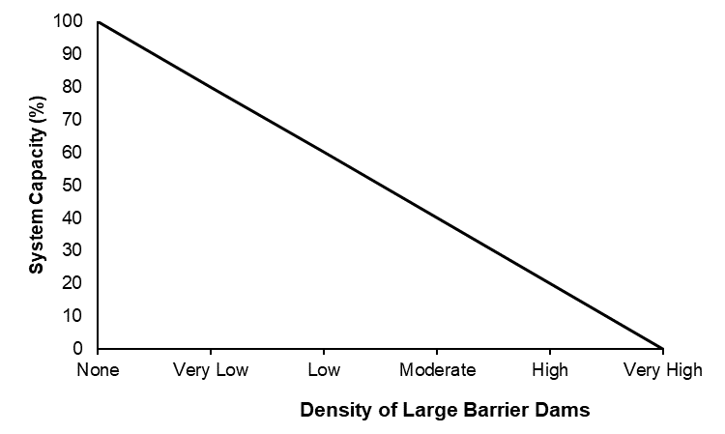

**Figure X** Stressor-response curve depicting the expected relationship between large barrier dams and the system capacity of Athabasca rainbow trout populations. System capacity (0-100%) is a measure of adult density relative to a maximum capacity of 100%.

Detail formal sensitivity analysis on input value and SR curve and how we came up with each

Competition or Replacement

Within the Joe model, replacement of native Athabasca rainbow trout with brook trout or non-native rainbow trout is accounted for as the percent of habitat lost to each of these non-native species. To calculate their overall effect on the predicted system capacity of the HUC, the two are first summarized together in an additive manner such that they are summarized as the total percent of habitat lost to non-native species due to replacement.

1. Replacement: Brook Trout

Brook trout is a wide-spread, invasive species that may compromise Athabasca rainbow trout populations through competition (Magoulick and Wilzbach 1998; Popowich 2005; Donald 1987). In theory, competition should mainly occur when resources are limited, or the system is near carrying capacity (Dunham et al. 2002). Therefore, researchers should carefully examine available evidence to determine if brook trout are actually out-competing and replacing Athabasca rainbow trout, or if they are taking advantage of resources made available as a result of declining Athabasca rainbow trout abundance due to other stressors (e.g., habitat changes, over-exploitation), as is found in exotic Atlantic salmon apparently outcompeting steelhead trout (Volpe et al., 2001). In this latter and expected case, the brook trout are therefore replacing niche vacancies from missing rainbow trout, rather than displacing existing trout. The stressor-response curve (Figure x) evaluates the expected impact of brook trout on Athabasca rainbow trout status relative to the carrying capacity of the system.

Joe Model Data Input: The amount of habitat in which brook trout are replacing Athabasca rainbow trout was compared to historic Athabasca rainbow trout habitat in each HUC 10 watershed. Replacement will be considered as occurring in streams and stream reaches (order ≥2) which once held rainbows, but now contain predominately brook trout at densities that suggest the system is at or near carrying capacity (estimated at approximately 80 brook trout/300m, but dependent on stream size). Biologists used stream electrofishing survey data from FWMIS (query August 2019) to highlight survey locations with high brook trout densities and then, often with local area knowledge, estimated the stream distance upstream and downstream from this survey location with high brook trout densities. The input value was the % of stream habitat (kilometers) occupied by brook trout at hypothesized carrying capacity relative to the kilometers of available Athabasca rainbow trout habitat within a HUC10.

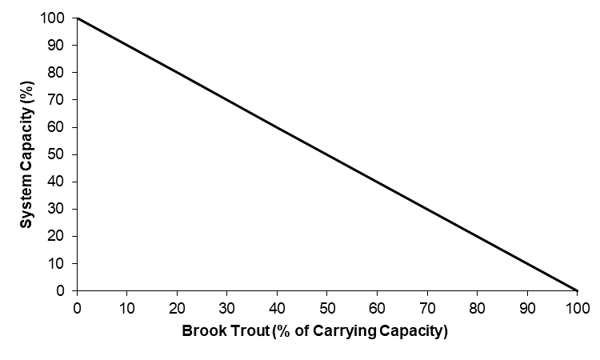

**Figure X** Stressor-response curve depicting the expected relationship between brook trout replacement and the system capacity of Athabasca rainbow trout populations. System capacity (0-100%) is a measure of adult density relative to a maximum capacity of 100%.

Detail formal sensitivity analysis on input value and SR curve and how we came up with each

1. Replacement: Non-Native Rainbow Trout

While the mechanisms of non-native rainbow trout invasiveness have not been fully explored, it is assumed that niche overlap results in the replacement, but not displacement of native Athabasca rainbow trout. In this theoretical framework, Athabasca rainbow trout are initially lost because of another threat (e.g., overfishing), and the direct stocking or migration of stocked rainbows results in the replacement of native fish with non-native fish. This assumed no competitive advantage from non-native fish, but is simply a factor of few native fish being in the area to allow a natural recovery, in area, versus abundant, locally stocked fish. This follows the overall theory of competition/replacement/exclusion of Volpe et al. (2000). Participants at the workshop did not know of any system where native fish were abundant, yet were replaced by non-native fish. The stressor-response curve (Figure x) evaluates the possible impact of non-native rainbow trout on Athabasca rainbow trout status relative to the carrying capacity of the system.

Joe Model Data Input: The amount of habitat in which non-native rainbow trout are replacing Athabasca rainbow trout was compared to historic Athabasca rainbow trout habitat in each HUC 10 watershed. Replacement will be considered as occurring in streams and stream reaches (order ≥2) which once held native rainbows, but now contain non-native rainbow trout. Using the available genetic data, stream segments identified as near pure (Qi=0.95-0.99) or hybrid (Qi<0.95). Where genetic data was unavailable, these estimates were supplemented with local area knowledge and professional opinion. The input value was the % of stream habitat (kilometers) occupied by non-native rainbow trout relative to the kilometers of available Athabasca rainbow trout habitat within a HUC10.

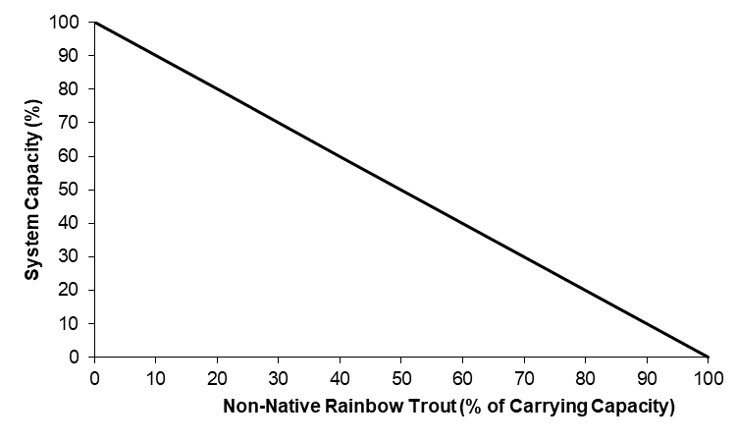

**Figure X** Stressor-response curve depicting the expected relationship between non-native rainbow trout replacement and the system capacity of Athabasca rainbow trout populations. System capacity (0-100%) is a measure of adult density relative to a maximum capacity of 100%.

Detail formal sensitivity analysis on input value and SR curve and how we came up with each

Water Quality, Water Quantity and Contaminants

1. Water Quality: Phosphorus

Phosphorus is a major driver of primary production in aquatic ecosystems that affects other biotic and abiotic factors. Low-level inputs of phosphorus during oligotrophic stream fertilization projects in B.C. have resulted in increased fish size and abundance due to substantial increases in trophic productivity with limited impact to water quality (Koning et al. 1998). However, higher levels of nutrient inputs lead to stream eutrophication and degraded water quality, including reduced nocturnal dissolved oxygen in summer (Chung 2013; Jacobsen and Marin 2008) and overall anoxic conditions that can impair biodiversity (Meijering 1991). For example, degraded stream habitats and winterkill conditions in Alberta foothills were correlated with theoretical increases in phosphorus runoff due to land use at the watershed scale (Norris 2012).

The phosphorus response curve was developed using observed data on an inferred stressor level and current FSA ranking. FSA rankings for adult bull trout in 73 HUC 8 watersheds across Alberta have been determined (AEP 2013). Stressor levels for phosphorus in these watersheds were obtained using ALCES™ online, using runoff coefficients of phosphorus for different land-use types (see data input). Phosphorus runoff was measured as a potential loading value for each HUC8 watershed (tonnes/ha/year), as the effect of absolute phosphorus loading on aquatic ecosystems has been well studied for over 50 years (Wetzel 1975). Given that we couldn’t conduct a similar analysis for Athabasca rainbow trout (all populations are high risk), we hypothesized that the relationship for bull trout adult status versus phosphorus was likely similar to what would be observed for Athabasca rainbow trout.

Potential phosphorus loading (tonnes/ha/year) stressor-response curve was derived by: a) using logistic regression to develop a statistical model relating probability of being within a given FSA category to the log-transformed stressor level; and, b) converting this statistical model into a stressor-response curve relating phosphorus/sediment to a percent reduction from a pristine reference condition. Proportional-odds logistic regression was used as the response variable is a multinomial ordered variable (Venables and Ripley 2002). The proportional-odds assumption of independence among adjacent categories was assessed by comparing similarity of odds ratios among successive categories (Venables and Ripley 2002).

The stressor-response curve was derived from the proportional-odds logistic-regression models by estimating stressor-levels required for a 90% probability of falling within a given FSA category. This is similar logic to quantile regression (Cade and Noon 2003) that recognizes numerous unaccounted factors can be driving a response variable. FSA categories were converted to percent of reference condition using population percentages at transition points between adjacent FSA categories. To incorporate uncertainty into derivation of the stressor-response curve, 95% prediction intervals were plotted using Bayesian distributions for parameters from the proportional-odds logistic regression with non-informative priors (Gelman and Hill 2006, Gelman and Su 2018).

FSA adult ranking for bull trout in HUC 8 watersheds was rarely 3 or better when phosphorus loading potential was ≥0.1 tonnes/ha/year (Figure X). No watersheds with a FSA adult rank of 5 were observed. There was a significant phosphorus level effect (slope = -0.42, 95% profile confidence interval -0.65 to -0.21) with probability of a watershed being within a lower FSA rank increasing with phosphorus loading. From these probability distributions, the stressor-response for percentages of a reference population at a given phosphorus loading was developed (Figure x).

A major issue in assessing the importance of potential stressors in driving a response variable is collinearity amongst different stressors (Zuur et al. 2010). If different stressors are highly correlated, it is impossible to distinguish relative importance without further experimentation. There was a high degree of correlation between potential phosphorus loading (tonnes/ha/year) and the relative sediment increase (dimensionless) across the 73 watersheds (Pearson R = 0.62, 95% confidence interval 0.45 – 0.74). Thus, it was difficult in the available data to separate importance of phosphorus or sediment independently on bull trout. Our approach was to create two separate stressor-response curves (i.e., one for potential phosphorus loading independent of the sediment index and vice-versa) and acknowledge that the observed response could be driven by the other stressor. As the Joe model accumulates cumulative effects multiplicatively (additive on a proportional scale), treating these two curves separately would inappropriately overemphasize the expected response. To overcome this issue, we treated sediment and phosphorus in the Joe model using a limiting factor approach (i.e., the same approach used for August or February low-flow withdrawals). Simply, the Joe model selects the worst response from either the phosphorus or sediment stressor-response curves (but not both) and applies this in the cumulative effects model. Anytime a watershed shows either phosphorus or sediment to be a hypothesized key driver, it must be acknowledged that the other stressor (i.e., sediment or phosphorus, respectively) could be the driver given the collinearity.

Joe Model Data Input: The potential phosphorus loading (tonnes/ha/year) from 2010 was exported from ALCES Online ©. Total expected phosphorus export was calculated following the Event Mean Concentration method described in Donahue (2013) and is based on land cover type and annual precipitation within the natural region. Phosphorous runoff values were obtained from the Upper Bow River Basin Cumulative Effects Study (ALCES Group, 2012) and phosphorous delivery coefficients were obtained from Stelfox et al (2008). Total estimated phosphorous export was calculated in ALCES Online © within the spatial watershed unit of interest.

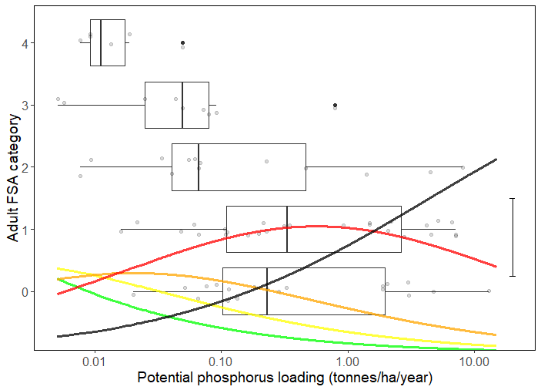

**Figure X** Distribution of bull trout adult FSA categories for 73 HUC 8 Watersheds in Alberta in relation to estimated phosphorus loading in 2010. Grey circles are the actual data points (jittered around the y-axis). Box-and-whisker plots show interquartile range, median, 1.5x interquartile range and outliers. Coloured lines are probabilities estimated from proportional-odds logistic regression of a watershed being in FSA 4 (green), FSA 3 (yellow), FSA 2 (orange), FSA 1 (red) or FSA 0 (black) for a given phosphorus level (vertical segment on right shows 25% probability). The sum of probabilities across all FSA categories for a specified phosphorus loading totals 1.

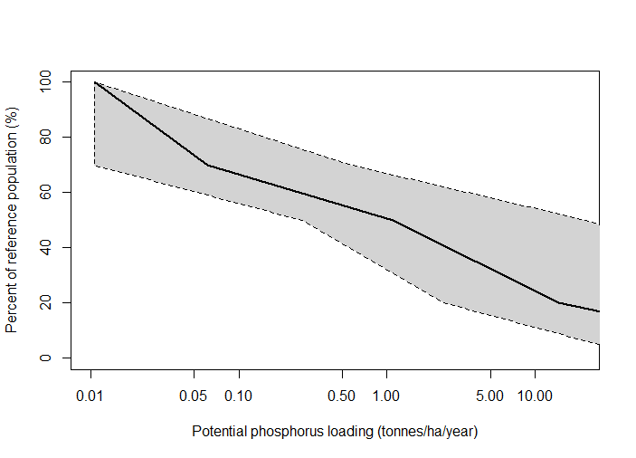

**Figure X** Stressor-response curve depicting the expected relationship between potential phosphorus loading (tonnes/ha/year) and the system capacity of Athabasca rainbow trout populations. System capacity (0-100%) is a measure of adult density relative to a maximum capacity of 100%. Black line is the median response for the Bayesian posterior estimate (vertices at 0.01,100; 0.06,70; 1.1,50; 14.2,20; 978,0). Grey region is the 95% Bayesian prediction interval (lower vertices: ≤0.01,100; >0.01,70; 0.27,50; 2.4,20; 61,0; and, upper vertices: 0.01,100; 0.6,70; 22,50; 991,20; 1.4e6,0).

Detail formal sensitivity analysis on input value and SR curve and how we came up with each

1. Water Quality: Sediment

Sedimentation can reduce the biological productivity of aquatic ecosystems and damage fish habitat (ASRD 2012). The amount of sediment a stream can transport is based on numerous factors including, but not limited to, precipitation, surface water transport, erosion, topography, geology and riparian vegetation (reviewed in Muck 2010). Anthropogenic disturbances (e.g., such as roads, Lachance et al. 2008) can produce substantial inputs of sediments into streams in excess of natural levels. These increased rates of sediment delivery can adversely affect Athabasca rainbow trout habitat and have lethal and sub-lethal effects throughout trout life history from egg incubation to adulthood (reviewed in Muck 2010).

Potential impacts caused by excessive suspended sediments are varied, complex and often masked by other concurrent activities (Newcombe 2003), making it difficult to establish the specific effects of sediment impacts on fish (Chapman 1988).

The sediment stressor-response curve was developed using observed data on inferred stressor level and current FSA ranking. FSA adult rankings for bull trout in 73 HUC 8 watersheds across Alberta have been determined (AEP 2013). Stressor levels for sediment in these watersheds were obtained using ALCES™ online, using runoff coefficient sediment for different land-use types (see data input). The dynamic pattern of sediment transport varies from watershed to watershed and aquatic ecosystems have adapted to the natural temporal and spatial pattern of this transport. As such, effects on fish from changes in sediment loading will be relative to natural conditions (Kemp et al. 2011). To capture relative change, sediment in the stressor-response curve was measured as potential sediment loading for 2010 (tonnes/ha/year) divided by potential sediment loading for 1910 (tonnes/ha/year). Given that we couldn’t conduct a similar analysis for Athabasca rainbow trout (all populations are high risk), we hypothesized that the relationship for bull trout adult status versus phosphorus was likely similar to what would be observed for Athabasca rainbow trout.

The sediment index (2010 loading/1910 loading) stressor-response curves were derived by: a) using logistic regression to develop a statistical model relating probability of being within a given FSA category to the log-transformed stressor level; and, b) converting this statistical model into a stressor-response curve relating sediment to a percent reduction from a pristine reference condition. Proportional-odds logistic regression was used as the response variable is a multinomial ordered variable (Venables and Ripley 2002). The proportional-odds assumption of independence among adjacent categories was assessed by comparing similarity of odds ratios among successive categories (Venables and Ripley 2002).

The stressor-response curve was derived from the proportional-odds logistic-regression models by estimating stressor-levels required for a 90% probability of falling within a given FSA category. This is similar logic to quantile regression (Cade and Noon 2003) that recognizes numerous unaccounted factors can be driving a response variable. FSA categories were converted to percent of reference condition using population percentages at transition points between adjacent FSA categories. To incorporate uncertainty into derivation of the stressor-response curve, 95% prediction intervals were plotted using Bayesian distributions for parameters from the proportional-odds logistic regression with non-informative priors (Gelman and Hill 2006; Gelman and Su 2018).

Compared to phosphorus, the data showed a much clearer separation among FSA categories with increasing sediment relative to background 1910 values (Figure X). An adult FSA category of 4 existed in watersheds when relative sediment increases were essentially non-existent. FSA categories of 1 or 0 dominated when sediment increased more than 3 fold over background levels. Not surprisingly, there was a significant and strong negative sediment effect on association with FSA categories (slope = -2.8, 95% profile confidence interval –3.8 to -2.0). The stressor-response curve is shown in Figure x.

A major issue in assessing the importance of potential stressors in driving a response variable is collinearity amongst different stressors (Zuur et al. 2010). If different stressors are highly correlated, it is impossible to distinguish relative importance without further experimentation. There was a high degree of correlation between potential phosphorus loading (tonnes/ha/year) and the relative sediment increase (dimensionless) across the 73 watersheds (Pearson R = 0.62, 95% confidence interval 0.45 – 0.74). Thus, it is difficult in the available data to separate importance of phosphorus or sediment independently on bull trout. Our approach was to create two separate stressor-response curves (i.e., one for potential phosphorus loading independent of the sediment index and vice-versa) and acknowledge that the observed response could be driven by the other stressor. As the Joe model accumulates cumulative effects multiplicatively, treating these two curves separately would inappropriately overemphasize the expected response. To overcome this issue, we treated sediment and phosphorus in the Joe model using a limiting factor approach (i.e., the same approach used for August or February low-flow withdrawals). Simply, the Joe model selects the worst response from either the phosphorus or sediment stressor-response curves (but not both) and applies this in the cumulative effects model. Anytime a watershed shows either phosphorus or sediment to be a hypothesized key driver, it must be acknowledged that the other stressor (i.e., sediment or phosphorus, respectively) could be the driver given the collinearity.

Joe Model Data Input: The sediment index is calculated as the total expected sediment export for the year of interest divided by the total expected sediment export before substantial industrial activity (i.e., 1910). Total expected sediment export was calculated following the Event Mean Concentration method described in Donahue (2013) and is based on land cover type and annual precipitation within the natural region. Sediment runoff values were obtained from the Upper Bow River Basin Cumulative Effects Study (ALCES, 2012) and sediment delivery coefficients were obtained from Stelfox et al. (2008). Total estimated sediment export was calculated in ALCES Online © within the spatial unit of interest.

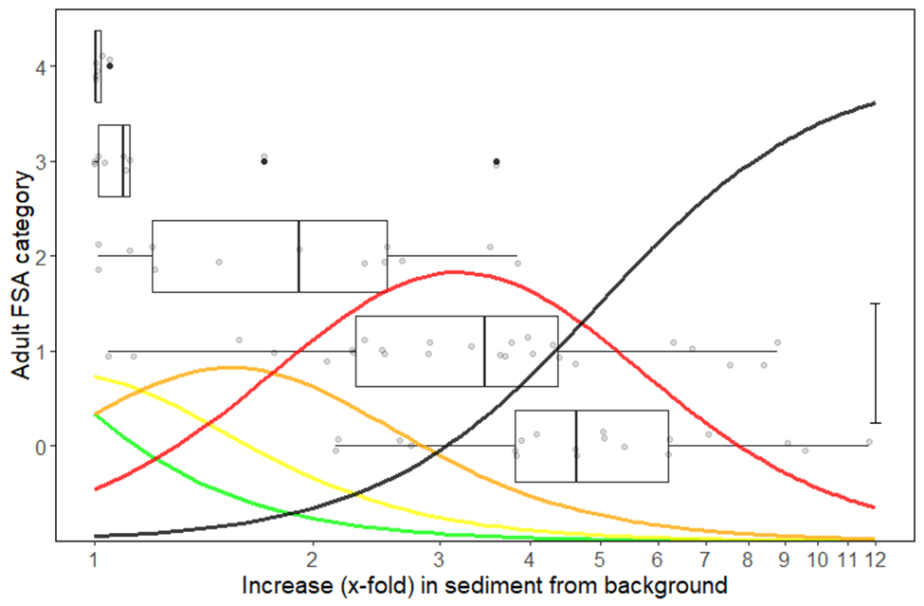

**Figure X** Distribution of bull trout adult FSA categories for 73 HUC 8 watersheds in Alberta in relation to estimated increase in sediment loading from background 1910 conditions. Grey circles are the actual data points (jittered around the y-axis). Box-and-whisker plots show interquartile range, median, 1.5x interquartile range and outliers. Coloured lines are probabilities estimated from proportional-odds logistic regression of a watershed being in FSA 4 (green), FSA 3 (yellow), FSA 2 (orange), FSA 1 (red) or FSA 0 (black) for a given sediment level (vertical line on right shows 25% probability). The sum of probabilities across all FSA categories for a specified sediment level totals 1.

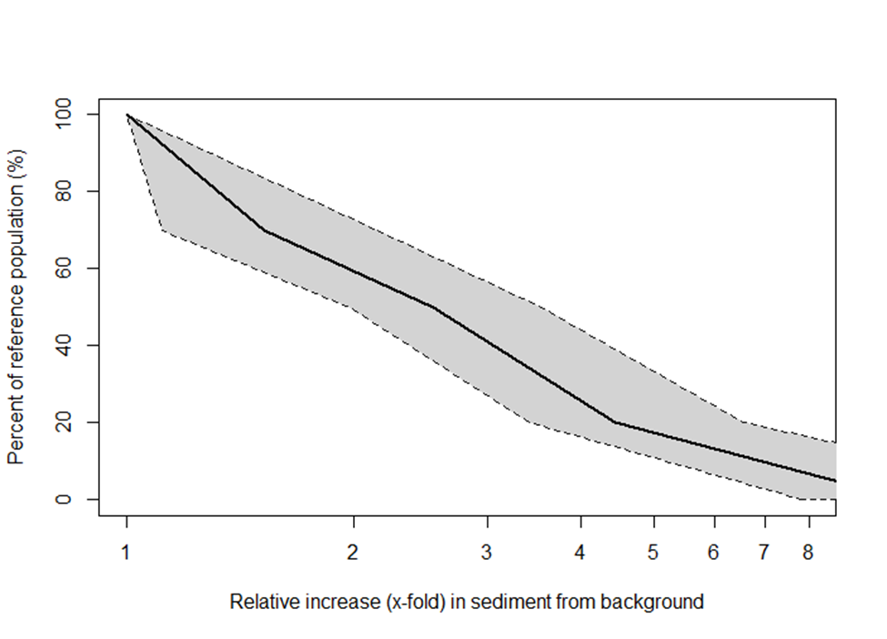

**Figure X** Stressor-response curve depicting the expected relationship between relative increase in sediment loading from background 1910 conditions and the system capacity of Athabasca rainbow trout populations. System capacity (0-100%) is a measure of adult density relative to a maximum capacity of 100%. Black line is the median response for the Bayesian posterior estimate (vertices at 1.0,100; 1.5,70; 2.5,50; 4.4,20; 10.8,0). Grey region is the 95% Bayesian prediction interval (lower vertices: 1.0,100; 1.1,70; 2.0,50; 3.4,20; 7.8,0; and, upper vertices: 1.0,100; 2.2,70; 3.5,50; 6.6,20; 19.2,0).

Detail formal sensitivity analysis on input value and SR curve and how we came up with each

1. Water Quantity: Surface Water Withdrawals

The effect of water withdrawals during February (winter) and August (summer) on Athabasca rainbow trout was investigated using a multi-step analytical approach based on the low-flow habitat performance measures developed by Hatfield and Paul (2015). First, it was assumed there was a 1:1 relationship between the minimum available habitat (bottleneck effect) and Athabasca rainbow trout population system capacity. To measure habitat, an index presented by Hatfield and Paul (2015) was used which: a) sets all flows >20% Mean Annual Discharge (MAD) to a habitat score of 1 (i.e., maximum suitability); b) has a habitat score of 0 at zero flow (i.e., no suitability); and, c) has a habitat score between 0 and 1 for flows between 0 and 20% MAD using a linear relation. This simple rating curve means that a flow of just under 20% MAD will score close to the maximum of 1, whereas a substantially lower flow will score proportionally less. The index was then used to determine the reduction in habitat scores from water withdrawals. Because withdrawals would have the greatest impact on the habitat score during low flows (i.e., < 20% MAD), percent withdrawal was determined for two periods of the year (August and February) and the lowest 10% of flows (i.e., Q90 or 90% exceedance flow) for these months. The approach was then applied to 37 rivers of varying size in Alberta that had year-round natural or naturalized (i.e., corrected for upstream water use) discharge and percent withdrawals ranging from 0–100% were modelled to assess the decrease in the habitat score from natural.

For February flow, all 37 rivers showed a similar linear response in the habitat score to water withdrawals. This average response was used as the basis for the stressor-response curve (Figure xA). For August flows, the rivers showed a highly variable response in the habitat score to water withdrawals, ranging from linear (similar to February) to curvilinear with little initial response but increasing as withdrawals increased. The 75th percentile regression using a general additive model (Koenker 2017) was used to capture the curvilinear relationship (Figure xB). The overall cumulative effects model only includes the season during which water withdrawals have the greatest effect on Athabasca rainbow trout as physical habitat is assumed to limit populations by the minimum and not the combined product of February and August habitat.

Joe Model Data Input: The percentage of water being withdrawn in the watershed of interest compared to natural low-flow discharge during February and August from that watershed. This value will be estimated using simple empirical relationships (Paul 2015, AEP, unpublished data) that relate mean annual discharge to the 90th exceedance flow (a measure of low flow) for either February or August using the dataset for 37 rivers described above. Estimated water use is derived from ALCES online (Total Water Use indicator). An estimator of mean annual discharge per HUC watershed is taken from ALCES online and is: MAD=Mean Annual Precipitation-Mean Annual Actual Evapotranspiration.

1. 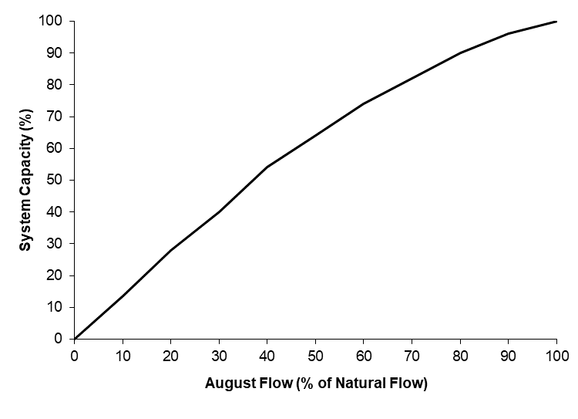 **B)**

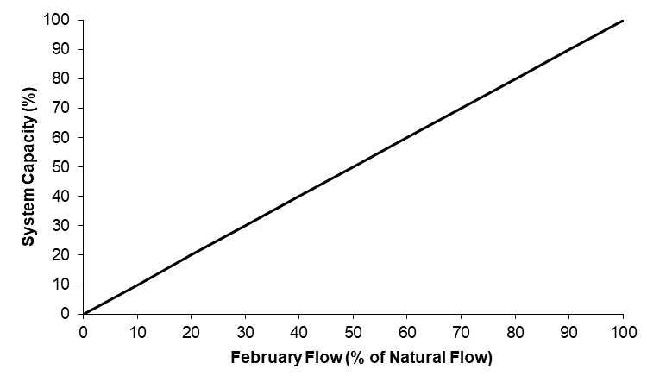

**Figure X** Stressor-response curve depicting the expected relationship between A) February flow, and B) August flow and the system capacity of Athabasca rainbow trout populations. System capacity (0-100%) is a measure of adult density relative to a maximum capacity of 100%.

Detail formal sensitivity analysis on input value and SR curve and how we came up with each

1. Flow Regime: Modification of Timing and Frequency of Peak-Flow Events

For fish in flowing waters, changes in the magnitude and frequency of peak flow events may impact the sustainability of populations. For instance, for trout species increased discharge during spring runoff and additional peak flow events throughout the year may result in downstream displacement of emerging fry (Ottaway and Clarke 1981) and also have negative effects on spring-spawning species that may be prey for trout (e.g., Seegrist and Gard 1972). Further, Jensen and Johnsen (1999) observed a negative correlation between year-class strength of two fall spawning salmonids and size of peak flood during the spring. There is also evidence that increased frequency of peak flow events can result in short and long term changes to river morphology that would impact trout, such as a reduction of habitat complexity and quantity of pool habitat (Lyons and Beschta 1983; Everest et al. 1985; Bonneau and Scarnecchia 1998) and the formation of an “oversized” channel. In several lotic trout Joe Models, fisheries biologists captured changes to flow in an index of potential hydrologic change to provide a qualitative description that captures the differences in the magnitude and frequency of peak flow events relative to the historic condition of the watershed. The potential for hydrologic change in watersheds was considered negligible when < 20% of the watershed was disturbed land (i.e., human footprint), low to moderate when 20–50% of the watershed was disturbed, and high when >50% of the watershed was disturbed (Figure xA). These thresholds are similar to Equivalent Clear-cut Area hazard categories recommended by Alberta Forestry and Agriculture (Stednick 1996; Guillemette et al. 2005; Mike Wagner pers. comm.). In the absences of other impacts, it was assumed that trout populations are resilient to a low degree of change and could persist, albeit at very low density, in watersheds where hydrologic change is high (Figure xB).

Joe Model Data Input: Total footprint area (%) at the spatial watershed unit of interest is determined in ALCES Online ©.

1. **B)**

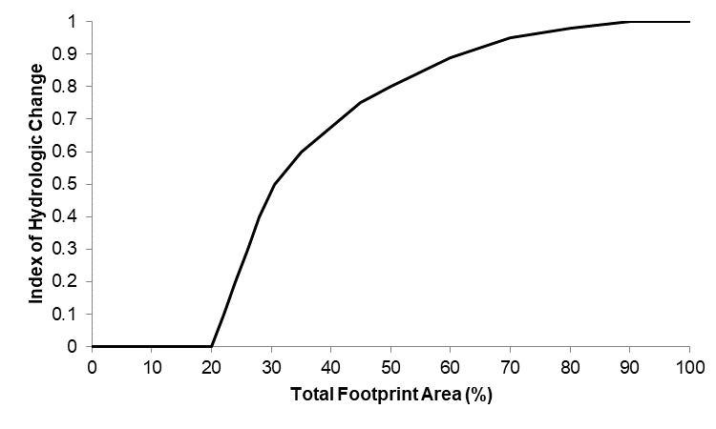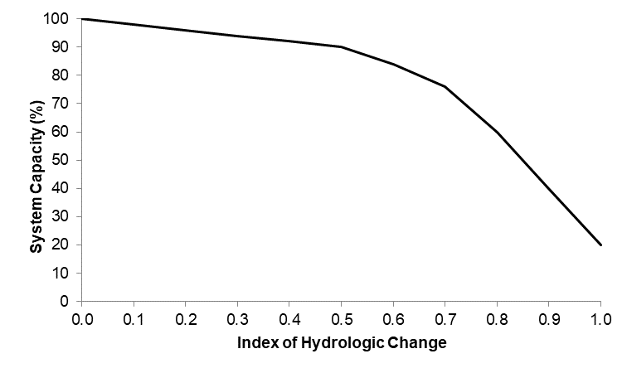

**Figure X** Stressor-response curve depicting the hypothesized relationship between A) total human footprint area and the index of hydrologic change, and B) the predicted effect of hydrologic change on the system capacity of Athabasca rainbow trout populations. System capacity (0-100%) is a measure of adult density relative to a maximum capacity of 100%.

Detail formal sensitivity analysis on input value and SR curve and how we came up with each

1. Selenium Effects

Selenium is a naturally-occurring element, necessary in trace amounts for metabolic processes but toxic at high concentrations (Frost and Lish 1975; Wang and Gao 2001). A variety of natural and human causes can lead to increases in selenium in fish, including open-pit mining that exposes limestone, increases in sedimentation and run-off, and atmospheric deposition from coal-burning power plants (Barceloux 1999; Lemly 2004). High concentrations of selenium have been detected in east slopes streams in Athabasca rainbow trout range, apparently caused by open-pit coal mining (Palace et al. 2004). Extensive reviews of selenium in Alberta fishes and waters are found in Fortin (2010) and Pilgrim (2012).

Selenium stressor-response curves for Athabasca rainbow trout were derived based on the research of Pilgrim (2012). Units of selenium concentration that best described population-level effects on rainbow trout was egg Se (microg/g wet-weight) (Figure x).

Joe Model Data Input: Derived from local studies on egg SE concentration when Se is expected to be an anthropogenic factor.

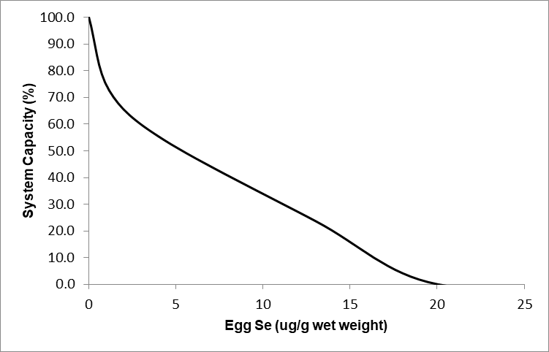

**Figure X** Stressor-response curve depicting the expected relationship between egg selenium (ug/g wet wt) and the system capacity of Athabasca rainbow trout populations. System capacity (0-100%) is a measure of adult density relative to a maximum capacity of 100%.

Disease: Whirling Disease

Whirling disease has been detected in some Alberta watersheds, but not in Athabasca rainbow trout ranges, in spite of extensive testing (i.e.,87 sites tested in Athabasca rainbow Trout watersheds during 2016, 2017 and 2019, all tests negative for whirling disease, as of January 2020, M. Veillard, pers. comm. 22 January 2020). The parasite (*Myxobolus cerebralis*) can cause high levels of juvenile mortality, and rainbow trout in other jurisdictions have been particularly susceptible (Vincent 1996; Nehring and Walker 1996). No specific studies on the vulnerability of Athabasca rainbow trout to whirling disease have been conducted, and it is possible that native stocks of fish are more resistant than hatchery-origin stocks (Baerwald et al. 2011). However, if whirling disease is detected in Athabasca rainbow trout streams, it is prudent to manage the effects using information from studies on other strains of rainbow trout.

The stressor-response curve was derived from an Alberta trout age-class cohort model, using variable survival rates on juvenile trout (Sullivan and Spencer 2016). The population-level effects of whirling disease can be simulated at low, moderate or high levels of risk. This should be qualitatively determined using three factors; the prevalence of whirling disease in the watershed (low, moderate or high), the stream temperature (optimum of 10 0C– 150C mean warmest month = high risk, lower risk at cooler and warmer temperatures), and the gradient of the stream (low risk >4%, moderate risk 2 – 4%, high risk <2% gradient) (Figure x). This follows the Alberta risk assessment concepts for whirling disease (Paul and Reilly 2016). We expect that as Alberta biologists learn more about whirling disease and the key factors that influence its establishment and severity (e.g. *t. tubifex* density, sediment type, water temperature etc.), and we have the input data to support inclusion within the Joe model, that this stressor-response curve will be refined.

Joe Model Data Input: Mainly from studies on trout and char in other jurisdictions, modelled assessments and age-cohort models. No empirical studies on Athabasca rainbow trout and whirling disease are currently available (July 2017). This is a categorical variable, set to none (0) when whirling disease detection is negative (as distinct to “no testing for whirling disease”). The sensitivity of Athabasca rainbow trout to whirling disease is influenced by water temperature and water velocity. If whirling disease is detected in the Athabasca drainage, following Paul and Reilly (2016) the risk of whirling disease should be mapped in GIS along the stream network in the Athabasca drainage. For a given watershed, the whirling disease severity was ranked as the mean associated risk for a stream or river in the watershed. Using the mean (rather than the maximum) gives fisheries managers an estimate of the expected whirling disease risk in the overall watershed, but does not account for the possibility of local ‘hot spots’ based on temperature or velocity. Disease severity can be adjusted according to local knowledge and updated laboratory results.

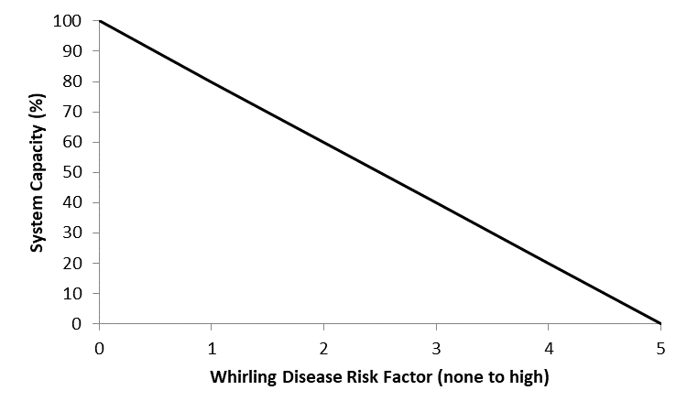

**Figure X** Stressor-response curve depicting the expected relationship between whirling disease risk and the system capacity of Athabasca rainbow trout populations. System capacity (0-100%) is a measure of adult density relative to a maximum capacity of 100%.

Habitat Loss

Direct habitat loss can occur in part of Athabasca rainbow trout range. This type of loss is defined as the removal of portions of a natural stream, or replacement of portions of a natural stream with a different landscape feature. Strip-mining for coal in this region has completely destroyed some stream sections. They may be replaced with open-pit lakes, or with channeled stream analogs (i.e., a ditch).

The stressor-response curve for habitat loss is simply the percentage of stream habitat lost or converted to non-Athabasca rainbow trout habitat (Figure x).

Joe Model Data Input: GIS-derived estimates of stream habitat converted to non-Athabasca rainbow trout habitat in the spatial watershed unit of interest.

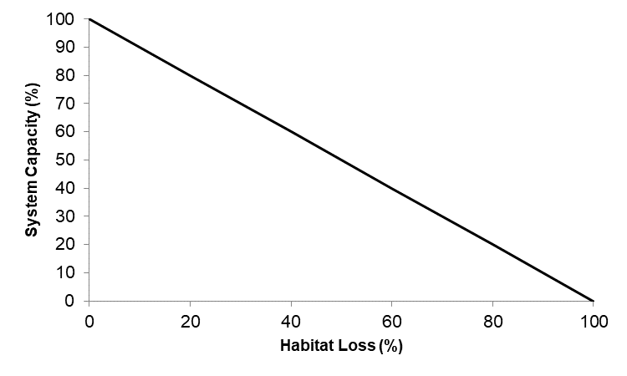

**Figure X** Stressor-response curve depicting the expected relationship between habitat loss (%) and the system capacity of Athabasca rainbow trout populations. System capacity (0-100%) is a measure of adult density relative to a maximum capacity of 100%.

Results

Present the results of the study or investigation in whatever format suits the particular project. As there will be a variety of projects, the results may be presented in a variety of ways. A key point will be to indicate where the data is going to be permanently stored and how it will be stored (disk, CD, paper file, etc.). There may be some reports with data that should not be made generally available to the public. If so, include the reasons for the decision and make recommendations on the limits to distribution of the report. See “Sensitive Information” section in report guidelines.

Specific Joe modelling content considerations:

* Provide a general overview of modelling vs measured FSA density results. How does the model fare vs measured FSA density status? Why might it be different? What is the overall status of your species across its Alberta range?
* [insert map figure]
* [insert figure- see provided template in provided excel spreadsheet]
* [insert table- see provided template in provided excel spreadsheet]
* What were the results (including the uncertainty analysis)?
* What were the major driving threats? Climate change predictions, and where should we concentrate our efforts?
* Run through scenarios and where would see measurable gains

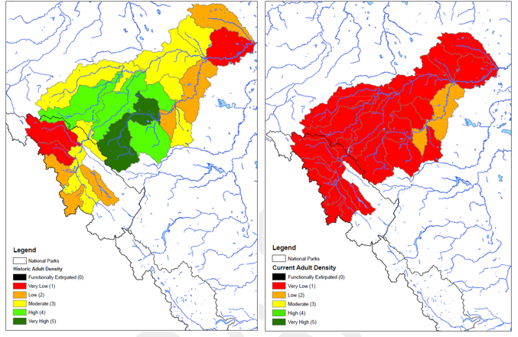

**Figure X.** Historical and current adult status of [insert species name] based on Alberta’s [insert year] Fisheries Sustainability Assessment (FSA) ranking. Ranks applied to [insert number] populations, defined as [insert HUC level watershed/lakes]

**Table X.** Empirically estimated historic and current adult status ranks, and modelled adult status for [insert species name].



**Figure X.** Adult status of [insert species name] based on historical estimates, current empirical measures of abundance, and modelled cumulative effects on abundance.

Modelled Watershed Threat Assessments

* In a couple sentences, describe the overall findings. Did some threats continually float to the surface as important?
* [Insert table summarizing major threats by HUC watershed

Detailed Watershed by Watershed summary

* Discuss the threats with the highest impact. Why are they they highest? Where are the major impacts coming from? Across the watershed? Or several ‘hot spots’? Consider adding a map with land use layers or satellite imagery

Sensitivity and Robustness Analysis

* TBD. Ideas: discuss which ones a sensitivity analysis was run on, how sensitivity analysis was completed, and general results across the range

Discussion

Provide the analysis and discussion of results, assessment of project goals, recommendations and suggestions for further study. The length and complexity of this section will vary depending on the type of project.

Overview of adaptive management as a tool

Management Implications and Future Directions

This section will include a general description of the importance of the study and the application of the results to the management, conservation or recovery of the species (or habitat). Indicate if any of the recommendations have been implemented or incorporated into management actions. Identify data gaps, need for additional work and priority for additional work. Provide an assessment of how well the project met goals or commitments identified in the Introduction.

|  |  |  |  |
| --- | --- | --- | --- |
| Table Heading | Table Heading | Table Heading | Table Heading |
| * Table copy style | * Table copy style | * Table copy style | * Table copy style |
| * Table copy style | * Table copy style | * Table copy style | * Table copy style |
| * Table copy style | * Table copy style | * Table copy style | * Table copy style |
| * Table copy style | * Table copy style | * Table copy style | * Table copy style |

Literature Cited

List citations here. In general, follow format from Status of Alberta Wildlife Series reports as closely as possible. To see examples of those reports, go to http://aep.alberta.ca/fish-wildlife/species-at-risk/species-at-risk-publications-web-resources/. Make sure all references cited in the text are included in the Literature Cited and vice versa. All entries are first placed alphabetically, and then chronologically. Entries for a single authored article are placed before those entries co-authored by the same senior author. Co-authored entries are first entered alphabetically by the surname of the senior author, then alphabetically (not chronologically) by the surname of the second author. For example:

Jones, R.L. 1984…

Jones, R.L. 1986….

Jones, R.L., and J.M. Smith. 1982….

Jones, R.L., P.T. Thomas and J.M. Smith. 1988…

Jones, R.L., and P.M. Young. 1986…

Jones, R.L., and T.D. Zimms. 1984…etc.

Provide total page numbers for each book and report. Note that in the body of the text, multiple citations are given in chronological order. Provide the author’s name and date of the publication within the text of the report (i.e., Brown 1998).

Citations for reports in the series should use the following format:

Author. Year. Title. Alberta Environment and Parks, Fish and Wildlife Policy Branch, Alberta Species at Risk Report No. XXX. Edmonton, AB. (#pp if available)

Citations for interim/internal reports should use the following format:

Author. Year. Title. Alberta Environment and Parks, Fish and Wildlife Policy Branch, Edmonton, AB. Interim/Internal Report. (#pp if available)

For electronic references, please be particularly careful when recording the URL, and be sure to record the date that the site was last updated, if available, or the date the site was accessed. As websites often change, please use a non-electronic resource wherever possible (although websites are appropriate for status designations) and consider printing off a page or downloading an electronic copy of documents if the reference is likely to disappear (or ask contracted author to do so).

Note on Personal Communications:

Authorities or experts on the species in question who were contacted and are referenced in the text (e.g., B. Smith pers. comm.) should be listed in alphabetical order in the Acknowledgements section. Where appropriate, please include the affiliation (in brackets) with each individual’s name.

Alberta Athabasca Rainbow Trout Recovery Team (AARTRT). 2014. Alberta Athabasca Rainbow Trout Recovery Plan, 2014-2019. Alberta Environment and Sustainable Resource Development, Alberta Species at Risk Recovery Plan No. 36. Edmonton, AB. 111 pp.

Alberta Environment and Parks (AEP). 2013. Bull Trout Fish Sustainability Index. Alberta Fish and Wildlife Policy Branch, Edmonton, Alberta. <https://www.alberta.ca/bull-trout-fsi.aspx>.

Alberta Environment and Sustainable Resource Development (AESRD). 2013a. Standards for the ethical use of fishes in Alberta. 5 pp.

Alberta Environment and Sustainable Resource Development (AESRD). 2013b. Standard for sampling of small streams in Alberta. 18 pp.

Alberta Fisheries Management Division (AFMD). 2004. Electrofishing Policy Respecting Injuries to Fish. 3 pp.

Alberta Sustainable Resource Development (ASRD). 2012. Bull Trout Conservation Management Plan 2012-17. Alberta Sustainable Resource Development, Species at Risk Conservation Management Plan No. 8, Edmonton, AB. 90 pp.

Baerwald, M.R., J.L. Petersen, R.P. Hedrick, G.J. Schisler and B. May. 2011. A major effect quantitative trait locus for whirling disease resistance identified in rainbow trout (*Oncorhynchus mykiss*). Heredity 106:920-926.

Barceloux, D.G. 1999. Selenium. Clinical Toxicology37: 145-172.

Behnke, R.J. 2002. Trout and salmon of North America. The Free Press, New York. 359 pp.

Bonneau, J.L. and D.L. Scarnecchia. 1998. Seasonal and diel changes in habitat use by juvenile bull trout (*Confluentus salvelinus*) and cutthroat trout (*Oncorhynchus clarki*) in a mountain stream. Canadian Journal of Zoology 76:783-790.

Burford, D.D., McMahon, T.E., Cahoon, J.E. and Blank, M. 2009. Assessment of trout passage through culverts in a large Montana drainage during summer low flow. North American Journal of Fisheries Management 29: 739–752.

Cade, B.S. and B.R. Noon. 2003. A gentle introduction to quantile regression for ecologists. Frontiers in Ecology and the Environment 1: 412–420.

Chapman, D. W. 1988. Critical review of variables used to define effects of fines in redds of large salmonids. Transactions of the American Fisheries Society 117: 1-21.

Chung, C. 2013. Diel oxygen cycles in the Bow River: Relationships to Calgary's urban nutrient footprint and periphyton and macrophyte biomass. MSc Thesis, University of Calgary, AB. 92 pp.

Clayton, T.B. 2001. Movements and status of Bull Trout (*Salvelinus confluentus*) in the Belly River, Alberta and Montana. Pages 141-145 in Brewin, M.K., A.J. Paul, and M. Monita, editors. Bull Trout II conference proceedings. Trout Unlimited Canada, Calgary, Alberta, Canada.

COSEWIC. 2014. COSEWIC assessment and status report on the Rainbow Trout *Oncorhynchus mykiss* Athabasca River populations in Canada. Committee on the Status of Endangered Wildlife in Canada. Ottawa. Xi + 60 pp.

CSAS REF

Donahue, W.F. 2013. Determining Appropriate Nutrient and Sediment Loading Coefficients for Modelling Effects of Changes in Landuse and Landcover in Alberta Watersheds. Water Matters Society of Alberta, Canmore, AB. 52pp.

Donald, D.B. 1987. Assessment of the outcome of eight decades of trout stocking in the mountain national parks, Canada. North American Journal of Fisheries Management 7:545-553.

Dunham, J., S.B. Adams, R.E. Schroetr and D.C. Novinger. 2002. Alien invasions in aquatic ecosystems: Toward an understanding of brook trout invasions and potential impacts on inland cutthroat trout in western North America. Reviews in Fish Biology and Fisheries, 12: 373-391.

Everest, F.H., N.B. Armantrout, S.M. Keller, W.D. Parante, J.R. Sedell, T.E. Nickelson, J.M. Johnston, and G.N. Haugen. 1985. Salmonids. In Management of wildlife and fish habitats in forests of western Oregon and Washington Edited by E.R. Brown. USDA Forest Service, Portland, Oregon, 199–230.

Federal Energy Regulatory Commission (FERC). 1995. Preliminary assessment of fish entrainment at hydropower projects, a report on studies and protective measures, volumes 1 and 2 (appendices). FERC Office of Hydropower Licensing, Washington, D.C. Paper No. DPR-10. June 1995 (volume 1) and December 1994 (volume 2).

Fortin, B.L. 2010. Selenium dynamics in Canadian Rocky Mountain lakes. M.Sc. thesis, Department of Biological Sciences, University of Alberta. Edmonton, Alberta. 130 pp.

Frost, D.V. and P.M. Lish. 1975. Selenium in biology. Annual Review of Pharmacology15: 259-284.

Gelman, A. and J. Hill. 2006. Data Analysis Using Regression and Multilevel/Hierarchical Models. Cambridge University Press.

Gelman, Andrew, and Yu-Sung Su. 2018. Arm: Data Analysis Using Regeression and Multilevel/Hierarchical Models. R package version 1.10-1. <https://cran.r-project.org/package=arm>   

GOA 2015- aboriginal treaty rights reference . Fish conservation and management strategy?

Guillemette, F., A.P. Plamondon, M. Prévost and D. Lévesque. 2005. Rainfall generated stormflow response to clearcutting a boreal forest: peak flow comparison with 50 world-wide basin studies. Journal of Hydrology 302:137-153.

Gunn, J.M, and Sein, R. 2000. Effects of forestry roads on reproductive habitat and exploitation of lake trout (*Salvelinus namaycush*) in three experimental lakes. Canadian Journal of Fisheries and Aquatic Sciences 57: 97–104.

Harper, D.J. and Quigley, J.T. 2000. No net loss of fish habitat: an audit of forest road crossings of fish-bearing streams in British Columbia, 1996–1999. Canadian Technical Report of Fisheries and Aquatic Sciences 2319: 43 pp.

Hatch Ltd. 2010. Alberta Utilities Commission update on Alberta’s hydroelectric energy resources. Final report prepared for the Alberta Utilities Commission, 26 Feb 2010.

Hatfield, T. and A.J. Paul. 2015. A comparison of desktop hydrologic methods for determining environmental flows. Canadian Water Resources Journal, 40:303-318.

Jacobsen, D. and R. Marin. 2008. Bolivian Altiplano streams with low richness of macroinvertebrates and large diel fluctuations in temperature and oxygen. Aquatic Ecology 42:643-656.

Jensen, A.J. and B.O. Johnsen. 1999. The functional relationship between peak spring floods and survival and growth of juvenile Atlantic Salmon (*Salmo salar*) and Brown Trout (*Salmo trutta*). Functional Ecology 13:778-785.

Johns, T. and T. Ernst. 2007. Culvert crossings as potential barriers to fish movement in the Kakwa River Watershed, Alberta. Alberta Conservation Association, Peace River, AB.

Johnston, F. D., J. R. Post, C. J. Mushens, J. D. Stelfox, A. J. Paul and B. Lajeunesse. 2007. The demography of recovery of an overexploited Bull Trout, *Salvelinus confluentus*, population. Canadian Journal of Fisheries and Aquatic Sciences 64:113–126.

Kemp, P., D. Sear, A. Collins, P. Naden and I. Jones. 2011. The impacts of fine sediments on riverine fish. Hydrological Processes 25:1800-1821

Koenker, R. 2017. quantreg: Quantile Regression. R package version 5.33. <https://CRAN.R-project.org/package=quantreg>

Koning, C., K. Ashley, P. Slaney and A. Paul. 1998. Stream fertilization as a fisheries mitigation technique for perturbated oligotrophic trout streams in British Columbia. Pages 109-120 in M.K. Brewin and D.M.A. Monita, tech. Cords. Forest-fish conference: land management practices affecting aquatic ecosystems. Proc. Forest-Fish Conf., May 1-4, 1996, Calgary, AB. Nat. Resource Canada, Edmonton, AB, Inf. Rep. NOR-X-356.

Kwain, W. 1975. Embryonic development, early growth, and meristic variation in rainbow trout (Salmo gairdneri) exposted to combinations of light intensity and temperature. Journal Fisheries Research Board of Canada 32: 397-402.

Lachance, S., Dube, M., Dostie, R. and Berube, P. 2008. Temporal and spatial quantification of fine-sediment accumulation downstream of culverts in brook trout habitat. Transactions of the American Fisheries Society 137: 1826-1838.

Lemly, A.D. 2004. Aquatic selenium pollution is a global environmental safety issue. Ecotoxicology and Environmental Safety59: 44-56.

Lindsay, E., L. Peterson, H. Tunna, J. Dubnyk and T. Urquhart. 2015. Late Fall Fisheries Investigations in Irrigation Canals of Southern Alberta, 2014 Trout Unlimited Technical Report No. AB-037.

Lyons, J.K. and R.L. Beschta. 1983. Land use, floods, and channel changes: Upper Middle Fork Willamette River, Oregon (1936–1980). Water Resources Research 19:463-471.

Ma, B., E. Parkinson and D. Marmorek. 2012. Using single species population models of Bull Trout, kokanee and arctic grayling to evaluate Site C passage alternatives. Site C Clean Energy Project Technical Data Report: Vol. 2, App. Q3, Attachment B.

MacPherson, L., M. Coombs., J. Reilly, M.G. Sullivan, and D.J. Park. 2014. A generic rule set for applying the Alberta Fisheries Sustainability Index, second edition. Alberta Environment and Sustainable Resource Development, Edmonton, AB. 51 pp.

MacPherson, L.M., M.G. Sullivan, A.L. Foote and C.E. Stevens. 2012. Effects of culverts on stream fish assemblages in the Alberta foothills. North American Journal of Fisheries Management 32: 480–490.

Martins, E., L. Gutowsky, P. Harrison, D. Patterson, M. Power, D. Zhu, A. Leake and S. Cooke. 2013. Forebay use and entrainment rates of resident adult fish in a large hydropower reservoir. Aquatic Biology 19: 253–263.

Macdonald ref Athabasca temp modelling

Magoulick, D.D. and M.A. Wilzbach.1998. Effect of temperature and macrohabitat on interspecific aggression, foraging success, and growth of brook trout and rainbow trout pairs in laboratory stream. Transactions of the American Fisheries Society 127:708-717.

McCusker, M., E. Parkinson and E.B. Taylor. 2000. Phylogeography of rainbow trout (*Oncorhynchus mykiss*) and its implications for taxonomy, biogeography, and conservation. Molecular Ecology 9:2089-2108.

McPhail, J.D. 2007. Freshwater fishes of British Columbia. University of Alberta Press, Edmonton, Alberta. 620 pp.

Meijering, M. P.D. 1991. Lack of oxygen and low pH as limiting factors for *Gammarus* in Hessian brooks and rivers. Hydrobiologia 223:159-169

Morita, K. and Yamamoto, S. 2002. Effects of habitat fragmentation by damming on the persistence of stream-dwelling charr populations. Conservation Biology 16: 1318–1323.

Muck. J. 2010. Biological effects of sedimentation on bull trout and their habitat – guidance for evaluating effects. U.S. Fish and Wildlife Service. Washington Fish and Wildlife Office. Lacey, WA.

Nehring, R.B. and P.G. Walker. 1996. Whirling disease in the wild: the new reality in the intermountain west. Fisheries 21:28-30.

Nelson, J. S. and M. J. Paetz. 1992. The fishes of Alberta. University of Alberta Press, Edmonton. 437 pp.

Newcombe, C. P. 2003. Impact assessment model for clear water fishes exposed to excessively cloudy water. Journal of the American Water Resources Association 39: 529-544.

Norris, A.P. 2012. Cumulative effects thresholds for arctic grayling in the Wapiti River watershed. MSc Thesis, Royal Roads University, BC. 53 pp.

Ottaway, E.M. and A. Clarke. 1981. A preliminary investigation into the vulnerability of young trout (*Salmo trutta*) and Atlantic salmon (*S. salar*) to downstream displacement by high water velocities. Journal of Fish Biology 19:135-145.

Palace, V.P., Baron, C., Evans, R.E., Holm, J., Kollar, S., Wautier, K., Werner, J., Siwik, P., Sterling, G., and Johnson, C.F. 2004. An assessment of the potential for selenium to impair reproduction in bull trout, *Salvelinus confluentus*, from an area of active coal mining. Environmental Biology of Fishes70: 169-174.

Park, D.J. 2006. Stream fragmentation by hanging culverts along industrial roads in Alberta’s boreal forest: assessment and alternative strategies. M.Sc. Thesis, University of Alberta, Edmonton, AB, 97pp.

Park, D., M. Sullivan, E. Bayne and G. Scrimgeour. 2008. Landscape-level stream fragmentation caused by hanging culverts along roads in Alberta's boreal forest. Canadian Journal of Forest Research. 38: 566–575.

Paul, A.J. and J. Reilly. 2016. Whirling disease –risk mapping for the Bow River Basin. Technical report for Fisheries Management, Alberta Environment and Parks. Cochrane, AB. 1 Sept 2016. 14 pp.

Pilgrim, N.L. 2012. Multigenerational effects of selenium in rainbow trout, brook trout, and cutthroat trout. M.Sc. thesis, University of Lethbridge. Lethbridge, AB. 123 pp.

Popowich, R.C. 2005. Determining bull trout (*Salvelinus confluentus*) habitat and prey selection using snorkel surveys and stable isotope analysis. M.Sc. Thesis, University of Alberta, Edmonton, AB. 62 pp.

Post, J., C. Mushens, A. Paul and M. Sullivan. 2003. Assessment of alternative harvest regulations for sustaining recreational fisheries: model development and application to Bull Trout. North American Journal of Fisheries Management 23: 22–34.

Rasmussen, J.B. and E.B. Taylor. 2009. Status of the Athabasca Rainbow Trout (*Oncorhynchus mykiss*) in Alberta. Fish and Wildlife Division, Species at Risk. Alberta Wildlife Status Report No. 66. 46 pp.

Reilly, J., R. Konynenbelt and S. Herman. 2016. Pinto Lake Bull Trout Recovery Action Plan 2015-2020. Alberta Environment and Parks, Fisheries Management, Rocky Mountain House, AB. 13 pp + 1 appendix.

Ricker, W.E. 1975. Computation and interpretation of biological statistics of fish populations. Bulletin of the Fisheries Research Board of Canada 191. Ottawa, ON. 401 pp.

Ripley, T., G. Scrimgeour, and M.S. Boyce. 2005. Bull trout occurrence and abundance influenced by cumulative industrial developments in a Canadian boreal forest watershed. Canadian Journal of Fisheries and Aquatic Sciences 62: 2431–2442.

Salow, T. and L. Hostettler. 2004. Movement and mortality patterns of adult adfluvial Bull Trout (*Salvelinus confluentus*) in the Boise River basin Idaho. U.S. Bureau of Reclamation, Denver, Colorado.

Scott, W.B. and E.J. Crossman. 1998. Freshwater fishes of Canada, Galt House Publishing, Oakville, Canada. 966 pp.

Scrimgeour, G., P. Hvenegaard, J. Tchir, S. Kendall and A. Wildeman. 2003. Stream fish management: cumulative effects of watershed disturbances on stream fish communities in the Kakwa and Simonette River Basins, Alberta. Alberta Conservation Association, Peace River and the Alberta Research Council, Vegreville, AB. Northern Watershed Project Final Report No. 3.

Seegrist, D.W. and R. Gard. 1972. Effects of floods on trout in Sagehen Creek, California. Transactions of the American Fisheries Society 101:478-482.

Stednick, J.D. 1996. Monitoring the effects of timber harvest on annual water yield. Journal of Hydrology 176:79-95.

Stelfox, B., M. Anielski, M. Carlson and T. Antoniuk. 2008. Alberta Southern East Slopes Integrated Land Management Pilot Project. Prepared for Alberta Environment and Alberta Sustainable Resource Development by the ASPEN Group. 55 pp.

Sullivan, M.G. 2007. Modelling potential effects of angling on recovery of Westslope cutthroat trout (*Oncorhynchus clarkii lewisi*) in Alberta. Alberta Fish and wildlife manuscript, May 2007. Edmonton. 26 pp.

Sullivan, M. G. 2014. The Bull Trout of Jacques Lake, Jasper National Park: a population in recovery. Alberta Cooperative Conservation Research Unit, Edmonton AB. 18pp.

Sullivan, M.G. and S. Spencer. 2016. Cumulative effect of whirling disease and fishing mortality on Alberta trout populations. Technical report, Fisheries Management, Alberta Environment and Parks. Edmonton, AB. 29 August 2016. 10 pp.

Taylor, E.B., P. Tamkee, G. Sterling and W. Hughson. 2007. Microsatellite DNA analysis of rainbow trout (*Oncorhynchus mykiss*) from western Alberta, Canada: native status and evolutionary distinctiveness of ‘Athabasca’ rainbow trout. Conservation Genetics 8:1-15.

Taylor, E.B. and M. Yau. 2013. Analysis of introgression between indigenous and introduced rainbow trout (*Oncorhynchus mykiss*) in western Alberta. Department of Zoology, University of British Columbia. 13 pp.

Underwood, K. and S. Cramer. 2007. Simulation of human effects on Bull Trout population dynamics in Rimrock Reservoir, Washington. American Fisheries Society Symposium 53:191-207.

Venables, W. N., and B. D. Ripley. 2002. Modern Applied Statistics with S. Springer. <https://doi.org/10.1007/978-0-387-21706-2_1>

Vincent, E.R. 1996. Whirling disease and wild trout: the Montana experience. Fisheries 21:32-33.

Volpe, J.P., B. R. Anholt and B. W. Glickman. 2001. Competition among juvenile Atlantic Salmon (*Salmo salar*) and steelhead (*Oncorhynchus mykiss*): relevance to invasion potential in British Columbia. Canadian Journal of Fisheries and Aquatic Sciences 58:197-207.

Walters, C. 1997. [Challenges in adaptive management of riparian and coastal ecosystems](https://www.ecologyandsociety.org/vol1/iss2/art1/). Conservation Ecology [online]1(2):1.

Wang, Z. and Y. Gao. 2001. Biogeochemical cycling of selenium in Chinese environments. Applied Geochemistry 16: 1345-1351.

Warren, M.L., Jr., and Pardew, M.G. 1998. Road crossings as barriers to small stream fish movement. Transactions of the American Fisheries Society 127: 637–644.

Wetzel, RG. 1975. Limnology, WB Saunders Company, Philadelphia, United States. 743 pp.

Zuur, A.F., E.N. Leno and C.S. Elphick. 2010. A protocol for data exploration to avoid common statistical problems. Methods in Ecology and Evolution 1:3-14.

Appendix/Appendices

Raw data could be included in one or more numbered appendix/appendices starting on a new page. If not, indicate in the results section where the data are stored (e.g., location of office, FWMIS, etc.). Pages in this section will be numbered as part of the report.